

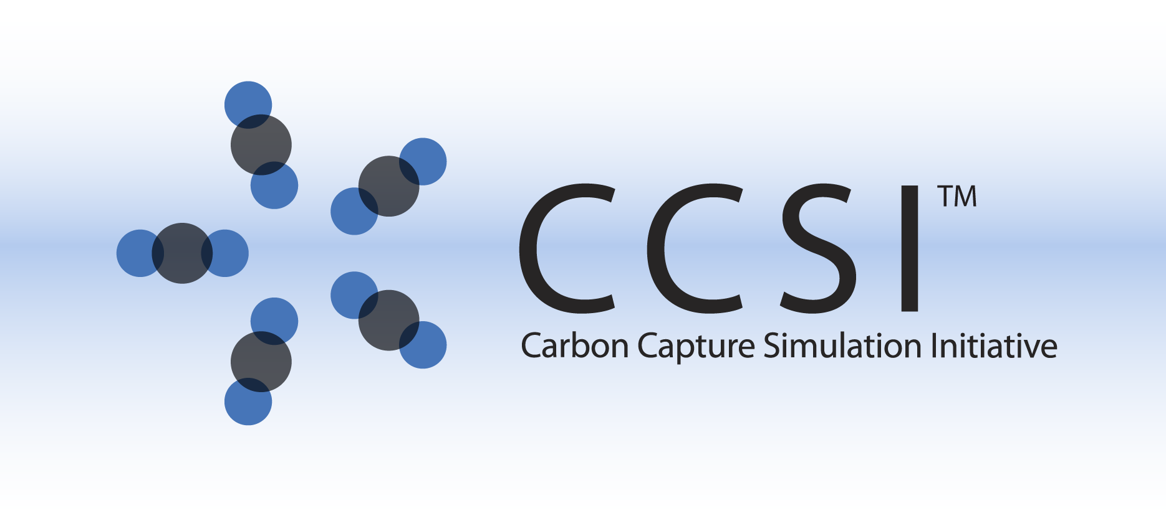

CCSI CFD Models

User Manual

Version 2016.02.00

February 2016



This material was produced under the DOE Carbon Capture Simulation Initiative (CCSI), and copyright is held by the software owners: ORISE, LANS, LLNS, LBL, PNNL, CMU, WVU, et al. The software owners and/or the U.S. Government retain ownership of all rights in the CCSI software and the copyright and patents subsisting therein. Any distribution or dissemination is governed under the terms and conditions of the CCSI Test and Evaluation License, CCSI Master Non-Disclosure Agreement, and the CCSI Intellectual Property Management Plan. No rights are granted except as expressly recited in one of the aforementioned agreements.

Table of Contents

CCSI CFD Models 1

1.0 Abstract 1

2.0 Reporting Issues 2

3.0 Version Log 2

Sorbents 4

MFIX Simulations for 1 Mega Watt Pilot Device 4

1.0 Installation 4

1.1 Prerequisites 4

1.2 Third Party Software 4

1.3 Product Installation 4

1.4 Build Custom Code for 1MW System Simulations 6

2.0 Simulations 6

2.1 Pre-Processing 6

2.2 Post-Processing 7

3.0 References 8

Subgrid Models for Drag and Heat Transfer in Gas-Particle Flows 9

1.0 Introduction 9

1.1 Motivating Example 9

2.0 Installation 10

2.1 System Requirements 10

2.2 Third Party Software 10

2.3 Product Usage 10

3.0 Test Case 11

3.1 Geometry 11

3.2 Subgrid Model Setup 12

3.3 Compiling and Running the Simulation 13

3.4 Verification 13

4.0 Example CaseS 16

5.0 Usage Information 17

5.1 Support 17

5.2 Restrictions 17

5.3 Next Steps 17

6.0 Debugging 17

6.1 How to Debug 17

6.2 Known Issues 17

6.3 Reporting Issues 17

7.0 References 17

DEM Attrition Model 18

1.0 Introduction 18

2.0 Constitutive Equations 18

2.1 Gas Phase 19

2.2 Motion of Particles 20

2.3 Gas-Solid Coupling 21

2.4 Particle Attrition 22

3.0 Numerical Simulation Example 23

4.0 Conclusion and Discussion 24

5.0 Acknowledgment 24

6.0 Example Input File 25

7.0 References 29

MFIX-DEM Pulverization Model 31

1.0 Installation 31

1.1 Prerequisites 31

1.2 Third Party Software 31

1.3 Product Installation 31

2.0 Simulations 32

3.0 References 33

Solvents 34

Simulating Liquid Film Flow over an Inclined Plate 34

1.0 Introduction 34

2.0 Fluent Simulation Case Study 34

2.1 Basic Problem Description 34

2.2 Simulation Overview and Prerequisites 35

2.3 Simulation Setup 36

2.4 Simulation Post-Processing 52

3.0 OpenFOAM Simulation Case Study 62

3.1 Simulation Overview and Prerequisites 62

3.2 Simulation Setup 62

4.0 References 62

OpenFOAM Wetted Wall Simulation Package 63

1.0 Introduction 63

2.0 Installation 63

2.1 Prerequisites 63

2.1.1 Hardware 63

2.1.2 Software 63

2.2 Third Party Software 64

2.3 Product Installation 64

3.0 Simulations 65

3.1 Input File 65

3.2 Output 66

3.3 Post-Processing 66

3.4 Overall Simulation Procedure Summary 67

4.0 Theoretical Background 68

5.0 Case Study 69

5.1 Geometry 70

5.2 Boundary and Initial Conditions 70

5.3 Run in Serial or Parallel 71

6.0 Reporting Issues 71

7.0 References 72

List of Figures

Figure 1: Schematics of the test case: 3D domain with heat transfer cylinders (left), 2D cross-section domain with heat transfer cylinders (middle), and 2D cross-section domain with subgrid model (right), where DelP denotes a pressure drop in the vertical direction and IC denotes initial conditions. The dashed lines represent periodic boundaries. The gas-solid mixture is initialized inhomogeneously with IC(1), IC(2), and IC(3) to aid in mixing. 11

Figure 2: Transient domain-averaged solids temperature for the test case, shown in red. The temperature asymptotes to thermal equilibrium at 293 K and should be near 294 K after 10 seconds. A high-resolution control solution is given in black with the standard deviation denoted by gray shading. 15

Figure 3: Schematics of the bubbling fluidized bed example case: 3D original domain with heat transfer cylinders (left, cylinders not-to-scale), 3D domain with subgrid model (middle), and simplified 2D cross-section domain with subgrid model (right), where BC denotes boundary conditions and IC denotes initial conditions. The blue IC(2) section represents the porous media phase used to model the unresolved immersed cylinders. 16

Figure 4: Two-dimensional rectangular jet cup with bottom gas inlet. 23

Figure 5: Transient load response (Intel Fortran compiler used). 33

Figure 6: Schematic of the computational flow domain – liquid flows down from top of the inclined smooth plate. 35

Figure 7: GUI components. 36

Figure 8: Dialog box for reading a case file (*.cas). 37

Figure 9: Graphic window with mesh displayed. 37

Figure 10: Materials window. 38

Figure 11: Phases window. 39

Figure 12: Cell Zone Conditions window. 40

Figure 13: Boundary Conditions bottom window. 41

Figure 14: Boundary Conditions Inlet Mixture window. 42

Figure 15: Boundary Conditions Inlet Solvent window. 42

Figure 16: Solution Controls window. 43

Figure 17: Residual Monitor window. 44

Figure 18: Surface Monitor window. 45

Figure 19: Solution Initialization Hybrid window. 46

Figure 20: Solution Initialization Adapt Region window. 47

Figure 21: Solution Initialization Patch window. 48

Figure 22: Autosave window. 49

Figure 23: Run Calculation window. 50

Figure 24: Run Calculation Calculate window. 51

Figure 25: Graphics and Animations Contours window. 53

Figure 26: Graphics and Animations Contours Mesh Display window. 54

Figure 27: Graphics and Animations Bottom Wall and Contour window. 55

Figure 28: Graphics and Animations Contours Solvent window. 56

Figure 29: Graphics and Animations Save Picture window. 57

Figure 30: Graphics and Animations Iso-Surface window. 58

Figure 31: Reports Surface Integrals window. 59

Figure 32: Reports Volume Integrals window. 60

Figure 33: Reports Surface Integrals window. 61

Figure 34: Input directories and files. 65

Figure 35: Schematic picture of the geometry. 69

List of Tables

Table 1: MFIX Keywords for the Subgrid Models 11

Table 2: Simulation Parameters 23

Table 3: Values of Input Parameters 71

To obtain support for the products within this package, please send an e-mail to   
[ccsi-support@acceleratecarboncapture.org](mailto:ccsi-support@acceleratecarboncapture.org).

CCSI CFD Models

1. Abstract

This product bundle contains all the device scale Computational Fluid Dynamics (CFD) models developed by the Carbon Capture Simulation Initiative (CCSI). They are organized by application area: sorbent-based capture and solvent-based capture. The CFD models are categorized as follows:

Sorbent-Based Capture:

1. CCSI Validation and Uncertainty Quantification Hierarchy for CFD Models: This product and methodology aims to provide quantitative confidence on CFD simulations of large to full scale carbon capture systems by the coupling simpler physical systems and upscaling to larger systems. A multi-tier methodology is proposed which divides the complexities of the full scale system into simpler sub problems.
2. Device Scale CFD Models for Sorbent: This product suite first contains the full scale high fidelity CFD model files for the adsorber unit of the 1MWe solid sorbent carbon capture system. This product also includes all the bench-scale C2U models from cold flow, non-reactive hot flow to fully coupled reactive flow in an effort to build up the validation and calibration hierarchy. It applies hierarchical model calibration and validation procedures in predicting device-scale CO2 adsorption. Users are suggested to follow the product installation guide to install the models and run the simulations, and to consult the corresponding CCSI milestone report for the detailed uncertainty quantification procedures.
3. Filtered Models for Geometric Upscaling: Because of the extreme disparity between the particle size and the overall dimension of the adsorber, explicit resolving the small-scale flow structures and heat transfer cylinders is computationally prohibitive. To enable accurate macroscopic predictions using coarse-grid simulations, various subgrid filtered models are developed by CCSI. These filtered models account for the presence of unresolved physics and geometry via constitutive subgrid equations, and they include: (1) cylinder-suspension drag,   
   (2) cylinder-suspension heat transfer, and (3) gas-particle interphase drag in MFIX. The   
   cylinder-based models are valid for an array of horizontal tubes immersed in the flow. In the simulations, the cylinders are replaced by an effective stationary porous media, occupying the same volume as the cylinders and the drag and heat transfer are modified through source terms added to the governing equations.
4. CCSI Attrition and Pulverization Model: Particle attrition is frequently encountered during the processing and handling of mesoporous particles in chemical processing, where the particles suffer progressive loss of material as a result of collisions and friction. In fluidized bed reactors, particle size reduction due to attrition can result in agglomeration and poor fluidization, and the generation of fine debris may further constitute health hazards, leading to environmental pollution. A discrete element method (DEM)-based attrition model was developed to investigate the attrition of initially monodispersed solid particles in a jet cup. Particle size reduction due to chipping and abrasive wear from particle-particle and particle-wall interactions were considered and explicitly implemented into the simulation. The attrition models can be used to study the effects of operational factors, such as jet velocity, particle size, solid density, and jet cup design on the attrition propensity. The Coal Pulverization Model, which was developed by extending the CCSI DEM-based modeling capability, is also included in this product category.

Solvent-Based Capture:

1. A Validation Hierarchy for CFD Models of Solvent-Based Carbon Capture Systems:   
   A hierarchical validation strategy has been laid out for the CCSI CFD modeling of full scale solvent-based carbon capture systems. The goal of the validation and UQ analysis is to quantify the predictive confidence of the CFD simulations for a specific solvent-based capture system of interest.
2. Liquid Film Flow over an Inclined Plate: This product contains the CCSI developed capability in predicting interfacial and wetted areas and film thickness for liquid film flow over an inclined plate. Volume of fluid (VOF)-based multiphase flow simulation is developed for film flow over an inclined plate. The model can be used to systematically study the effects of a wide range of parameters, including inlet cross section, flow rate, plate inclination angle, range of solvent properties, and contact angles on the flow characteristics. Based on results of rigorous and extensive simulations, scaling theory was also developed for interfacial and wetted areas and film thickness.
3. Wetted Wall Column (WWC) Models for Effective Mass Transfer and Reaction Parameters: This product suite contains the VOF-based CFD models for predicting the gas/solvent interactions in a WWC experiment, and it includes WWC models on hydrodynamics, hydrodynamics with mass transfer, and finally hydrodynamics with mass transfer and absorption reactions. Both experimental and simulation conditions are statistically designed, and the BSS-ANNOVA-based calibration process is demonstrated in this product suite. The posterior distributions of effective mass transfer coefficient with quantified uncertainty for the WWC can be obtained for solvents with different physical and chemical properties. This product represents one of the unit problems in enabling an at-scale prediction for a solvent-based packed column absorber.
4. Reporting Issues

To report an issue, please send an e-mail to [ccsi-support@acceleratecarboncapture.org](mailto:ccsi-support@acceleratecarboncapture.org).

1. Version Log

| Product | Version Number | Release Date | Description |
| --- | --- | --- | --- |
| **CCSI CFD Models** | **2016.02.00** | **02/28/2016** | **2016 February Release** |
| Subgrid Models for Drag and Heat Transfer in Gas-Particle Flows | 2016.02.0 | 03/31/2015 | Update models for improved stability and versatility. |
| **CCSI CFD Models** | **2015.10.00** | **11/20/2015** | **2015 November IAB Release** |
| OpenFOAM Wetted Wall Simulation Package | 2015.10.00 | 11/20/2015 | 2015 November IAB Release |
| Subgrid Models for Drag and Heat Transfer in Gas-Particle Flows | 2015.10.0 | 10/31/2015 | Updated Models and Cylinder-area calculations. More stable and accurate. |
| Subgrid Models for Drag and Heat Transfer in Gas-Particle Flows | 2015.03.0 | 03/31/2015 | Update models for MFIX2014-1. Added limiter for stability. |
| MFIX Simulations for 1 Mega Watt Pilot Device | 2015.01.3 | 07/07/2015 | ONEMWCFD-7 |
| MFIX Simulations for 1 Mega Watt Pilot Device | 2015.01.2 | 06/19/2015 | ONEMWCFD-7 |
| MFIX Simulations for 1 Mega Watt Pilot Device | 2015.01.1 | 03/02/2015 | ONEMWCFD-6 |
| MFIX Simulations for 1 Mega Watt Pilot Device | 2015.01.0 | 01/15/2015 | Initial Release |
| DEM Attrition Model | 2014.10.0 | 10/31/2014 | 2014 October IAB Release-Maintained |
| MFIX-DEM Pulverization Model | 2014.10.0 | 10/31/2014 | 2014 October IAB Release |
| Simulating Liquid Film Flow over an Inclined Plate | 2014.10.0 | 10/31/2014 | 2014 October IAB Release |
| Subgrid Models for Drag and Heat Transfer in Gas-Particle Flows | 2014.10.0 | 10/31/2014 | 2014 October IAB initial release of subgrid models package. |
| DEM Attrition Model | 2013.10.0 | 09/30/2014 | Initial Release |

Sorbents

MFIX Simulations for 1 Mega Watt Pilot Device

1. Installation

CCSI 1MW simulations are custom MFIX simulations. For that reason, the general installation procedure in this user manual follows that of MFIX [1]. In this session, only the 1MW specific installation procedure will be covered in details, leaving the general MFIX steps referring to the MFIX manual.

* 1. Prerequisites

The hardware and software prerequisites follow exactly that of MFIX [1].

* 1. Third Party Software

Open-source, multi-platform data analysis and visualization application ParaView is recommended for the MFIX simulation post-processing purpose. Users can download ParaView software online from <http://www.paraview.org/>.

Users can choose other similar visualization tools (for example, *Visit*) for the post-processing need.

* 1. Product Installation

This session will only describe the steps to build CFD models for 1MW CFD simulations. It is assumed that users have downloaded MFIX source files of version 2014-1, set environment variables and alias, and built mfix.exe on their chosen platform under $InstallDir/mfix/model. Users can build either a serial version or a parallel version of mfix.exe following instructions in [1].

Download file named CCSI_1MWCFD.tgz from the following URL: <https://www.acceleratecarboncapture.org/product/cfdmodelsbundle>.

Unzip the file, the user will get three directories: src, docs, and scripts.

The following files are under src directory:

calc_mu_s.f

allocate_arrays.f

check_data

check_data_30.f

drag_gs.f

drag_ss.f

ic_mod.f

init_namelist.f

namelist.inc

rrates0.f

set_ic.f

solve_energy_eq.f

source_u_s.f

source_v_s.f

species.inc

usr0.f

usr_init_namelist.f

usr_mod.f

usrnlst.inc

usr_rates.f

This Installation Guide/User Manual file CCSI_Software_Install_1MW.docx is available under docs directory.

The script files, which are useful for pre- and post-processing of the 1MW CFD simulations, are under scripts directory:

PP1MW.pl

PostMfix.pm

MyMath.pm

Util.pm

mfix.dat

mfix.mod

Modify1MW2.pl

RunCase

RunAll.pl

ProcessAll.pl

* 1. Build Custom Code for 1MW System Simulations

The 1MW system custom code should be built on top of MFIX official release of September 2014 (Version 2014-1). This release can be downloaded from MFIX web site: [https://mfix.netl.doe.gov/mfix/download-mfix](https://mfix.netl.doe.gov/mfix/download-mfix/).

The installation from the official release should create and populate content under $InstallDir, i.e., $HOME/mfix.

Create a directory for 1MW, e.g., $HOME/CCSI/1MW, and copy all the custom source code files to the directory. In the 1MW directory type “sh $InstallDir/model/make_mfix” and follow instructions on [1] to build the model. The build process will compile object files and generate a custom mfix.exe in directory $InstallDir/mfix/model. Upon successful compilation, mfix.exe is also copied to $HOME/CCSI/1MW.

1. Simulations

A sample model input file mfix.dat for the 1MW simulation is included in the scripts directory. Users can choose to run serial or parallel version of the CFD simulation. For more details, please refer to [1] for general MFIX simulations.

The 1MW simulations consist of large number of simulations with 14 varying parameters with values designed by the uncertainty quantification (UQ) analysis. In the following, a brief instruction is provided to summarize the automation procedure that facilitates the simulations and post-processing needs.

* 1. Pre-Processing

For both pre-processing and post-processing, the user should copy the Perl script files to $HOME/*bin* directory that is included in PATH variable:

PP1MW.pl

PostMfix.pm

MyMath.pm

Util.pm

Modify1MW2.pl

RunAll.pl

ProcessAll.pl

The user should create a run directory (i.e., *$RunDir=$HOME/1MWRuns*) and copy the following files to the run directory:

mfix.dat

mfix.mod

RunCase

UQ_351_design_32D_1MW.txt

For all Perl script files, the user must check and change the first line to the local Perl setting unless the file starts with

#!/usr/bin/env perl

Change this line accordingly to the user’s Perl script bin directory

use lib "/pic/people/kevinlai/bin";

For the run script *RunCase*, the user must check and modify the following to conform to the local setting:

1. Linux/Unix bash setting.
2. Module loading: make it consistent with the compiler choice.
3. E-mail address.
4. Location of mfix.exe.
5. Limit on the total run time of the job allocation.
6. Command for a parallel run: currently it is “mpirun –np” but the user must check with his/her own Linux system setting.
7. If the number of processors is changed in the model file mfix.dat (i.e., NODESI * NODESJ * NODESK), make sure that the run script is modified to match the new value.
8. If mfix.exe is built serial, make sure NODESI= NODESJ=NODESK=1 in mfix.dat.

After the modifications, run the script in *$RunDir:*

./Modify1MW2.pl

This script does the following:

1. Create 351 sub-directories, Case001 to Case351.
2. Copy mfix.mod to mfix.dat at each case sub-directory.
3. Modify mfix.dat according to the parameter settings defined in *UQ_351_design_32D_1MW.txt*.
4. Copy file *RunCase* to *RCasexxx* sub-directory (i.e., *RCase012*).

The user can go to each case sub-directory and run the batch script *RCasexxx*. Alternatively, the user can run all simulations by

./RunAll.pl

* 1. Post-Processing

The user can choose any post-processing tool to analyze the simulation result, e.g., the official MFIX post-mfix script or the open-source ParaView software.

Alternatively, a Perl script PP1MW.pl provided in this product can be used to automate the   
post-processing. Go to the simulation directory, e.g., *Case012* and run

PP1MW.pl –o result_file

The data in the result file should be self-explanatory. It prints all the QOIs (quantity of interest) for the 1MW system simulations.

1. References

[1] MFIX – Multiphase Flow with Interphase eXchanges, Version MFIX-2014-1. Download available for members: <https://mfix.netl.doe.gov/mfix/download-mfix>

Subgrid Models for Drag and Heat Transfer  
in Gas-Particle Flows

1. Introduction

Resolution of small-scale structures such as particle clusters and heat transfer cylinders is computationally impractical for large-scale devices. The inability to resolve these small-scale structures results in erroneous simulation predictions.

To enable accurate macroscopic predictions using coarse-grid simulations, subgrid filtered models are developed. These filtered models account for the presence of unresolved physics (e.g., drag [1] and heat transfer [2]) and geometry via constitutive subgrid equations.

This product is an implementation of theses subgrid models for: (1) cylinder-suspension drag [1],   
(2) cylinder-suspension heat transfer [2], and (3) gas-particle interphase drag in MFIX [3]. The   
cylinder-based models are valid for an array of horizontal tubes immersed in the flow. In the simulations, the cylinders are replaced by an effective stationary porous media, occupying the same volume as the cylinders. The drag [1] and heat transfer [2] are modified through source terms added to the governing equations.

* 1. Motivating Example

Consider a laboratory-scale 1 MW fluidized bed reactor measuring 1.33 × 6.88 m, with horizontal heat transfer cylinders of 1 cm diameter and solid-particles with a mean diameter (*dp*) of 118 µm. Typically this system would be discretized into a fine-mesh with grid cells of 10 × *dp* = 1.2 mm, resulting in a system of approximately 6.35 million cells. Alternatively, using a subgrid filtering approach and setting the (coarse) cell size to 156.8 × *dp* = 1.85 cm results in a system of 26,784 cells, a significant reduction.

1. Installation

These products do not require explicit installation; however, the user is required to have MFIX [3] made on their system to utilize the models. **Note:** These products were developed using source files from MFIX release 2015-1. Due to changes in the MFIX software structure, these models are not guaranteed to be backwards compatible with previous MFIX releases. To ensure proper functioning please use MFIX 2015-1.

* 1. System Requirements

These products require MFIX [3].

* 1. Third Party Software

Open-source, multi-platform data analysis, and visualization application *ParaView* is recommend for post-processing of the MFIX simulation and can be downloaded from [http://paraview.org](http://paraview.org/). Other similar visualization software (for example, Tecplot, VisIt) can also serve the same purpose.

* 1. Product Usage

It is assumed that the user has built the required MFIX source files and created the entire MFIX directory, as detailed in [3].

To use the filtered models, ensure the following model files (found in model) are in the *local* run directory (in addition to the mfix.dat input file):

check_data/check_solids_continuum.f

drag_gs.f

drag_ss.f

init_namelist.f

namelist.inc

run_mod.f

set_outflow.f

solve_energy_eq.f

source_u_s.f

source_v_s.f

In addition to the standard MFIX keywords, the subgrid filtered models require the following keywords as shown in Table 1.

Table 1: MFIX Keywords for the Subgrid Models

| Keyword | Type |
| --- | --- |
| **SG_CYL_HYDRO**  Flag for turning on/off the hydrodynamics (drag) subgrid model. | LOGICAL |
| **SG_CYL_ENERGY**  Flag for turning on/off the energy subgrid model (requires hydrodynamics model). | LOGICAL |
| **SG_CYL_D**  Cylinder diameter in cylinder subgrid model. | DOUBLE PRESISON |
| **SG_CYL_a**  Cylinder spacing in cylinder subgrid model. Refer to [1] for definition of spacing. | DOUBLE PRESISON |
| **SG_CYL_T**  Cylinder surface temperature in cylinder subgrid model. | DOUBLE PRESISON |

Follow the MFIX instructions [3] to build the MFIX executable in the *local* run directory. Upon successful compilation, an mfix.exe executable is created in the *local* run directory.

1. Test Case
   1. Geometry

To ensure the subgrid models are functioning correctly, a simple test case is includes. The test case is a 2D periodic domain simulating flow over two cooling cylinders. The mixture is initialized to a hot temperature and after some time the system reaches a thermal equilibrium equal to the cooling cylinders. The domain geometry is shown in Figure 1.

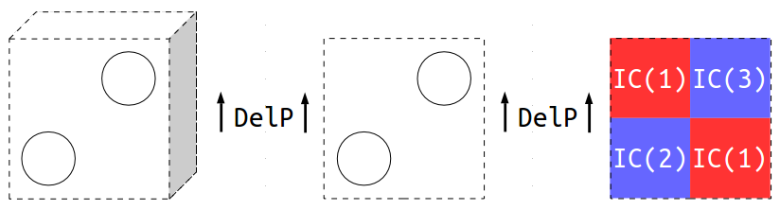

Figure 1: Schematics of the test case: 3D domain with heat transfer cylinders (left), 2D cross-section domain with heat transfer cylinders (middle), and 2D cross-section domain with subgrid model (right), where DelP denotes a pressure drop in the vertical direction and IC denotes initial conditions. The dashed lines represent periodic boundaries. The gas-solid mixture is initialized inhomogeneously with IC(1), IC(2), and IC(3) to aid in mixing.

* 1. Subgrid Model Setup

The subgrid models employ a secondary solid phase as a stationary porous media to occupy the volume of the unresolved cylinders. As a result, a second solid phase must be defined in the mfix.dat input file. The properties are arbitrary and are not used in any calculations; however, if they are highly unphysical, MFIX can error out. The property values below are recommended.

NMAX_s(2) = 1 # number of species

RO_s0(2) = 1.0 # density (kg/m^3)

D_p0(2) = 1.0 # particle diameter (m)

K_s0(2) = 0.1 # thermal conductivity (W/kg.K)

C_ps0(2) = 1000.0 # specific heat capacity (kJ/kg.K)

MW_s(2,1) = 1.0 # molecular weight (g/mol)

The stationary solids phase-fraction is set equal to the volume fraction occupied by the cylinders:

$$IC_EP_s(1,2)=\frac{π⋅{SG_CYL_D}^{2}}{2⋅{SG_CYL_a}^{2}} \\ =\frac{π⋅{0.01}^{2}}{2⋅{0.03}^{2}}⋅1 \\ =0.174.$$

Similarly, the average gas and solids (moving phase) fractions are calculated based on the remaining unoccupied volume, i.e., $1-IC_EP_s(1,2)$:

$$IC_EP_g'=\left(1-IC_EP_s\left(1,2\right)\right)⋅EP_g_{0} \\ =\left(1-0.174\right)⋅0.7 \\ =0.578$$

$$IC_EP_s'=\left(1-IC_EP_s\left(1,2\right)\right)⋅EP_s_{0} \\ =\left(1-0.174\right)⋅0.3 \\ =0.248.$$

It is important to ensure that the sum of the gas and solids fractions equal one, otherwise MFIX will error out. The inhomogeneities are introduced into the system by splitting the domain into four different sections and offsetting the gas and solid fractions, ensuring the average is still correct.

$$\left.\begin{matrix}IC_EP_g\left(1\right) =IC_EP_g'+0.05=0.628 \\ IC_EP_s(1,1)=IC_EP_s'-0.05=0.198 \end{matrix}\right\} red regions shown in Figure 1$$

$$\left.\begin{matrix}IC_EP_g\left(2\right) =IC_EP_g'-0.05=0.528 \\ IC_EP_s(2,1)=IC_EP_s'+0.05=0.298 \end{matrix}\right\} bottom-right blue region shown in Figure 1$$

$$\left.\begin{matrix}IC_EP_g\left(3\right) =IC_EP_g'-0.05=0.528 \\ IC_EP_s(3,1)=IC_EP_s'+0.05=0.298 \end{matrix}\right\} top-right blue region shown in Figure 1$$

The new subgrid keywords must be set according to the desired physics and geometry:

SG_CYL_HYDRO = .TRUE.

SG_CYL_ENERGY = .TRUE.

SG_CYL_D = 0.01

SG_CYL_a = 0.03

SG_CYL_T = 293.0

* 1. Compiling and Running the Simulation

Recompile MFIX (as instructed in Section 2.3 Product Usage) using the following Bash commands:

1. cd PATH_TO/test/ # change directory to test/
2. cp –r ../model/* . # copy model files (recursively) to run directory, test/
3. sh $MFIX/model/make_mfix # make MFIX, recompile with local source files, where $MFIX is the location of mfix/
4. mpirun –np $NSLOTS mfix # execute simulation in parallel, where $NSLOTS is the number of processors (i.e., NODESI*NODESJ*NODESK)
   1. Verification

To verify that the subgrid models are working correctly, the data must be post processed using MFIX’s included program, Post MFIX:

1. cd PATH_TO/test/ # change directory to test/
2. cd $MFIX/post_mfix # change directories to mfix/
3. ./make_post # compile Post MFIX
4. cd - # change directories back to test/
5. sh $MFIX/post_mfix/post_mfix

The user will be prompted to enter several parameters, use the same inputs as below in red:

Enter the RUN_NAME to post_process > **TEST**

********************************************************

read_res0 : code valid for running on 1 processor only

********************************************************

after call to calc distance

after call to calc_vol

*************************************************

0 - Exit POST_MFIX

1 - Examine/print data

2 - Write .RES from data in .SPx files

3 - Write .RES for a new grid, using old data

4 - Calculate miscellaneous quantities

5 - Print out variables

6 - Call user defined subroutine USR_POST

7 - Write a new SPx file with selected records

8 - Write new SPx files with time averaged data

9 - Perform ORNL calculations

10 - run scavenger code

*************************************************

Enter menu selection > **1**

Interactive data retrieval program. Type ? any time for help,

or press RETURN to select default values shown in parenthesis.

Write output using user-supplied precision? (T/F) **F**

Time: ( 0.000, 0.000) > **0,10**

Time average ? (N) > **N**

Variable: (EP_g ) > **T_s**

Solids phase: ( 1) > **1**

I range: ( 1, 1) > **2,31**

Average or sum over I? (N) > **Y**

J range: ( 1, 1) > **2,31**

Average or sum over J? (N) > **Y**

K range: ( 1, 1) > **1,1**

File: (* ) > **T_s.txt**

The post processor will write the domain-averaged solids temperature to an output file, T_s.txt. Open this file with any plotting software and plot the transient temperature. It should asymptote towards 293 K and be near 294 K by *t* = 10 seconds.

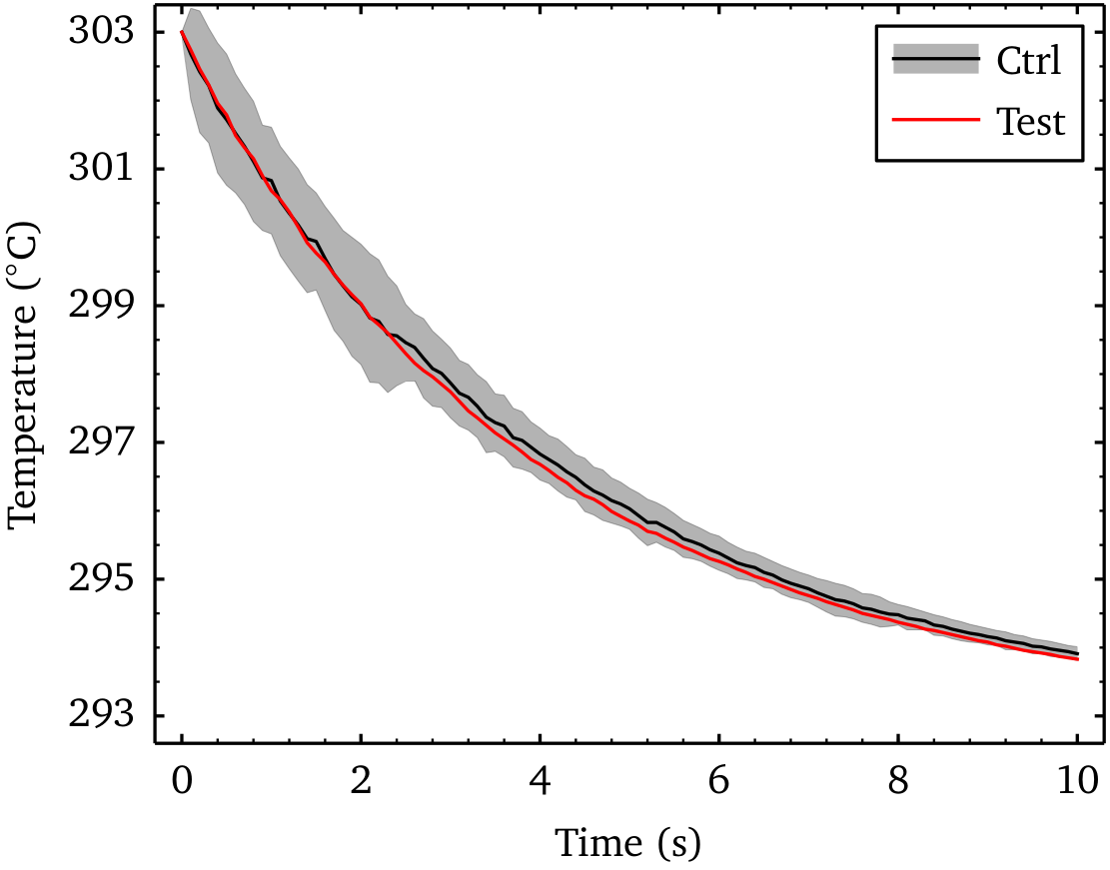

Figure 2: Transient domain-averaged solids temperature for the test case, shown in red. The temperature asymptotes to thermal equilibrium at 293 K and should be near 294 K after 10 seconds. A high-resolution control solution is given in black with the standard deviation denoted by gray shading.

1. Example CaseS

Two example cases of a heated fluidized bed has been included with the release of this product. Example1 demonstrates the system with non-reacting heated flow, employing the subgrid models for the hydrodynamics and heat transfer. Example2 utilizes the same system and includes reacting flow, simulating the adsorption of carbon dioxide onto solid sorbent particles. The following section describes these examples.

The geometry is based on the motivating example from Section 1.1 Motivating Example. The domain measures 1.33 × 6.88 m, with 1 cm diameter heat transfer cylinders (modeled as a porous media). The initial bed is empty. There is mass-inflow of particles and gas at the downchute that fill the reactor and a mass-inflow of gas at the base for fluidization. The mass-inflows are equalized by a mass-outflow area on the side for gas and solids and a pressure outlet above the freeboard. The walls are set to free-slip boundary conditions. Details can be found in the mfix.dat input files.

To compile and run the example case, refer to Section 3.3 Compiling and Running the Simulation.

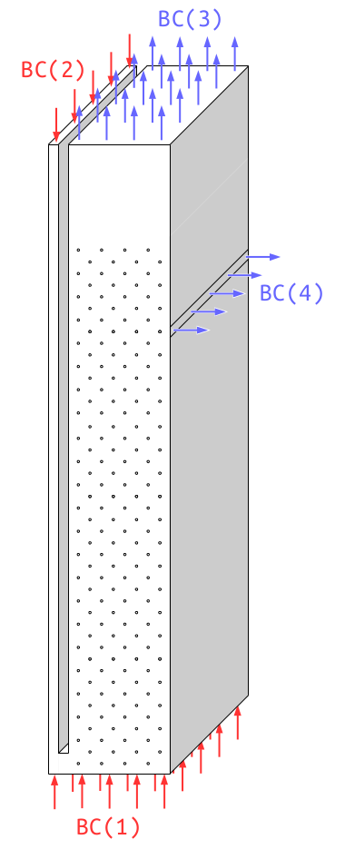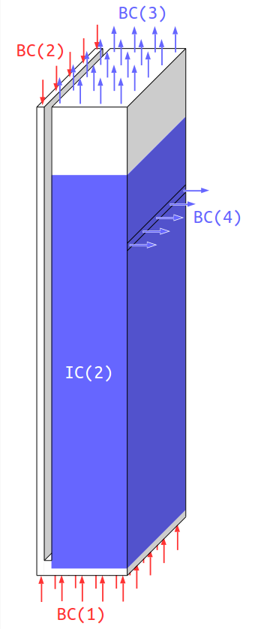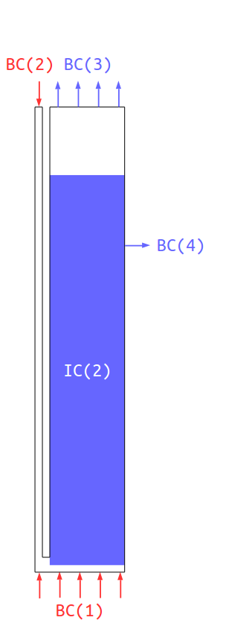

Figure 3: Schematics of the bubbling fluidized bed example case: 3D original domain with heat transfer cylinders (left, cylinders not-to-scale), 3D domain with subgrid model (middle), and simplified 2D cross-section domain with subgrid model (right), where BC denotes boundary conditions and IC denotes initial conditions. The blue IC(2) section represents the porous media phase used to model the unresolved immersed cylinders.

1. Usage Information
   1. Support

For technical support, send an e-mail to [ccsi-support@acceleratecarboncapture.org](mailto:ccsi-support@acceleratecarboncapture.org) and/or fill out the “Submit Feedback/Request Support” form available on the product distribution page.

* 1. Restrictions

This model does not support multiple solid-phases and requires the use of the Wen-Yu drag model. These models have not been verified in 3D.

* 1. Next Steps

The model is undergoing verification/validation and uncertainty quantification.

1. Debugging

Please refer to the following sections for debugging instructions and help contacts.

* 1. How to Debug

The cylinder-suspension drag model is largely implemented in drag_gs.f, drag_ss.f, source_u_s.f, and source_v_s.f, while the heat transfer model is largely implemented in solve_energy_eq.f. If the user is encountering errors, debug the problem systematically. Begin by simplifying the system and physics, and then systematically add in more details and physics. Once the problem is identified, refer to the aforementioned files for easy locating of bugs.

* 1. Known Issues

Energy conservation problems were observed with MFIX 2015-2 and periodic domain simulations.

* 1. Reporting Issues

To report an issue, please send an e-mail to [ccsi-support@acceleratecarboncapture.org](mailto:ccsi-support@acceleratecarboncapture.org).

1. References

[1.] A. Sarkar, X. Sun, S. Sundaresan, “Sub-grid drag models for horizontal cylinder arrays immersed in gas-particle multiphase flows.” *Chemical Engineering Science*, vol. 104, 18, pp. 399–412,   
December 2013.

[2.] W.A. Lane, E.M. Ryan, A. Sarkar, S. Sundaresan, “Sub-grid models for heat transfer in   
gas-particle flows with immersed horizontal cylinders,” *Chemical Engineering Science*, (submitted).

[3.] S. Benyahia, M. Syamlal, T.J. O’Brien, “Summary of MFIX Equations 2012-1”, From URL <https://mfix.netl.doe.gov/documentation/MFIXEquations2012-1.pdf>, January 2012.

DEM Attrition Model

1. Introduction

Particle attrition is frequently encountered during the processing and handling of solid granules in chemical, pharmaceutical, mineral, and food industries, where the particles suffer progressive loss of material as a result of collisions and friction [Hutchings, 1993]. Although such a process is favorable for particle size control in specific applications such as jet mills [Bentham et al., 2004], it is usually considered undesirable and even detrimental to the performance of gas-solid systems [Werther and Xi, 1993]. In fluidized bed reactors, for example, particle size reduction can result in agglomeration and poor fluidization [Pougatch et al., 2010], and the generation of fine debris may further constitute health hazards, leading to environmental pollution [Jørgensen et al., 2005].

The Carbon Capture Simulation Initiative (CCSI) is a collaborative effort between national laboratories, universities, and industry partners in the United States. Its goal is to develop and deploy computational tools to promote rapid commercialization of carbon capture technologies from discovery to development, demonstrate its use, and ultimately deploy these tools to hundreds of power plants, where   
post-combustion CO2 capture, using amine-based sorbents, is considered one of the candidate approaches. A predictive framework is presented here to accommodate and accelerate the catalyst screening and selection processes. A coupled computational fluid dynamics (CFD)-discrete element method (DEM) Attrition Model was developed to investigate the attrition of initially monodispersed solid particles in a jet cup. The viscous, compressible, high-speed gas flow was described using the Eulerian framework for the two-dimensional continuity and conservation of momentum equations, while the motion of the solid phase was resolved using the Lagrangian framework. Particle size reduction due to chipping and abrasive wear from particle-particle and particle-wall interactions were considered and explicitly implemented into the simulation. Changes of particle size distribution and the loss of fines under different flow conditions were studied. Effects of operational factors, such as jet velocity, particle size, solid density, and jet cup design on the attrition propensity are evaluated and discussed.

1. Constitutive Equations

The current model was developed using an open-source code, MFIX-DEM, where the carrier gas is treated as continuum and the disperse phase is represented by actual individual particles with the   
inter-collisions directly resolved using the soft-sphere approach [Cundall and Strack, 1978, Tsuji et al., 1993]. Although utilizing other methods such as the Eulerian treatment to describe the solid phase might provide advantages in computational efficiency of large scale simulations, the present approach largely preserves the direct physical interpretation of the particle dynamic characteristics including particle trajectory, particle-particle, and particle-fluid interactions by avoiding the averaging schemes [Li et al., 2000, Sanyal et al., 2005]. Heat transfer is not considered in this research, since the essential focus of this manual is the mechanical and fluid aspects of particle attrition.

* 1. Gas Phase

The conservation of mass and momentum for a gas-phase without chemical reactions or phase changes can be expressed as [Syamlal et al., 1993]:

|  |  |  |
| --- | --- | --- |
|  | $$\frac{∂(ε_{g}ρ_{g})}{∂t}+∇∙\left(ε_{g}ρ_{g}u_{g}\right)=0$$ | (1) |
|  | $$\frac{D}{Dt}\left(ε_{g}ρ_{g}u_{g}\right)=∇∙S_{g}+ε_{g}ρ_{g}g-I_{gs}$$ | (2) |

where the subscripts *g* and *s* denote the gas phase and the solid phase, respectively, *εg* is the gas volume fraction, *ρg* is the thermodynamic gas density, ***u****g* is the volume-averaged gas velocity, g is the gravitational acceleration, and ***I****gs* describes the accumulated momentum interactions between the gas phase and all of the solid phases. ***S****g* represents the gas-phase stress tensor and can be further written into ***S****g* = -*Pg****1*** + *τg* where, ***P****g* is the hydrostatic pressure, and _ g is the deviatoric shear stress. For an isotropic Newtonian fluid, *τg* is given as:

|  |  |  |
| --- | --- | --- |
|  | $$τ_{g}=2μ_{g}D_{g}+λ_{g}∇∙tr\left(D_{g}\right)1$$ | (3) |

where $D_{g}=\frac{1}{2}[∇V_{g}+{\left(∇V_{g}\right)}^{T}]$ is the rate of deformation tensor; *µg* and *λg* denote the shear and bulk viscosity, respectively.

The compressible gas is considered to obey the equation of state of ideal gases, which yields:

|  |  |  |
| --- | --- | --- |
|  | $$ρ_{g}=\frac{P_{g}M_{w}}{RT_{g}}$$ | (4) |

where *Mw* is the gas molecular weight, *Tg* is the absolute temperature, and *R* is the ideal gas constant.

* 1. Motion of Particles

Particles are generally assumed to be in spherical shape before and after attrition. In a Lagrangian reference frame, changes of their positions and velocities explicitly follow Newton’s laws:

|  |  |  |
| --- | --- | --- |
|  | $$\frac{dx^{i}}{dt}=u_{s}^{i}$$ | (5) |
|  | $$m^{i}\frac{du_{s}^{i}}{dt}=m^{i}g+F_{d}^{i}+F_{c}^{i}$$ | (6) |
|  | $$I^{i}\frac{dω^{i}}{dt}=J^{i}$$ | (7) |

where the superscript *i* denotes the *ith* particle, *m* is the particle mass, *I* is the moment of inertia, ***x*** is the position vector, ***u****s* and ***ω****i* are the translational and rotational solid particle velocity vectors, ***F****d* describes the gas-solid interaction, ***F****c* and ***J*** are the net contact force and torque resulting from particle   
inter-collisions.

The contact between any two solid spheres, i.e., the *ith* and the *jth* particles, is represented by   
spring-dashpot systems, which is also commonly referred to as the soft-sphere approach. The contact force ***F****ij* in either normal or tangential directions at any time *t* is decomposed into a conservative component $F_{ij}^{S}$ within the spring and a dissipative counterpart $F_{ij}^{D}$ within the dashpot as [van der Hoef   
et al., 2006]:

|  |  |  |
| --- | --- | --- |
|  | $$F_{nij}=F_{nij}^{S}+F_{nij}^{D}=-k_{n}δ_{n}-η_{n}u_{nij}$$ | (8) |
|  | $$F_{tij}=F_{tij}^{S}+F_{tij}^{D}=-k_{t}δ_{t}-η_{t}u_{tij}$$ | (9) |

where subscripts *n* and *t* denote the normal and tangential directions, *k* and *η* correspond to the spring constant and the dashpot coefficient, respectively, ***δ****n* is the overlap in the normal direction, while ***δ****t* is the tangential displacement.

In addition, to allow for finite Coulomb friction between particles, $F_{tij}=-μ_{s}\left|F_{nij}\right|t_{ij}$ is taken when $\left|F_{tij}\right|>μ_{s}\left|F_{nij}\right|$, where ***t****ij* is the tangential vector of the contact plane, and *µs* is the friction coefficient.

This then yields that the net force $F_{c}^{i}$ and the total toque acting on the ith particle, given as:

|  |  |  |
| --- | --- | --- |
|  | $$F_{c}^{i}=\sum_{\begin{aligned}j=1 \\ j≠i\end{aligned}}^{N}{(F_{ij}^{S}+F_{ij}^{D})}$$ | (10) |
|  | $$J^{i}=\sum_{\begin{aligned}j=1 \\ j≠i\end{aligned}}^{N}{(L^{i}×F_{tij}^{i})}$$ | (11) |

Here ***L****i* is the vector from the center of particle *i* to the contact point.

* 1. Gas-Solid Coupling

Although a variety of mechanisms have been identified for the interaction forces between the gas phase and the particulate phase [Johnson et al., 1990], only the buoyancy force caused by the gas pressure gradient and the drag force due to velocity difference between the phases are considered in the current study. The gas-particle interaction force ***F****d* is expressed as:

|  |  |  |
| --- | --- | --- |
|  | $$F_{d}=-∇P_{g}V_{p}+\frac{β^{k}V_{p}}{ε_{s}}\left(u_{g}-u_{s}\right)$$ | (12) |

where the subscript *k* represents the *kth* computational cell where the particle is located and *Vp* is the particle volume. *β* is the local phase momentum exchange coefficient. By further adopting the Gidaspow drag model [Gidaspow, 1994], we have

|  |  |  |
| --- | --- | --- |
|  |  | (13) |

in which the drag factor *CD* for a spherical shaped particle is given by

|  |  |  |
| --- | --- | --- |
|  | $$C_{D}=\left\{\begin{matrix}\frac{24(1+0.15{Re}_{g}^{0.687})}{Re_{g}} & Re_{g}≤1000 \\ 0.44 & Re_{g}>1000\end{matrix}\right.$$ | (14) |

Here $Re_{g}=\frac{ε_{g}ρ_{g}\left|u_{g}-u_{s}\right|d_{p}}{μ_{g}}$, and dp is the particle diameter. The mean gas-phase velocity in the *kth* cell is interpolated to the particle location for the drag force calculation. Then the net interaction force on each particle is projected back onto the Eulerian gas-phase grid following

|  |  |  |
| --- | --- | --- |
|  | $$I_{gs}=\frac{1}{V_{k}}\sum_{i=1}^{N}{F_{d}^{i∈k}ϕ(x^{i}, x_{k})}$$ | (15) |

where *Vk* is the *kth* cell volume and *ϕ* is a compact support kernel to determine the influence of the particle force on the grid node (Garg et al., 2012a).

* 1. Particle Attrition

The source of attrition generally includes both large-scale fragmentation of particles, where the cracks propagate through the whole bulk volume under extremely high stresses and finer-scale removal of surface material by wear [Bemrose and Bridgwater, 1987]. These sources can be subdivided into two distinct regimes: (1) abrasive wear and (2) erosive wear [Hutchings, 1993]. Abrasive wear results from the particles sliding or rolling over each other, while erosive wear results from particle collisions. These two mechanisms are considered and implemented into the dynamic simulation.

The material removal, due to plastic sliding in the abrasive wear, can be captured by the well-known Archard equation [Archard, 1953] as:

|  |  |  |
| --- | --- | --- |
|  | $$ξ_{a}=\frac{α_{a}F_{n}∆s}{H}$$ | (16) |

where *ξa* is the abrasion-induced volume fractional loss, *H* is the material hardness, *Fn* is the normal force, and ∆*s* is the sliding distance which is calculated based on the relative tangential displacement between two particles in contact. The dimensionless coefficient, *αa*, represents the wear severity.

Conversely, the erosive wear, especially for the semi-brittle materials, is considered to follow a chipping mechanism, where surface damage is largely caused by the formation of subsurface lateral cracks [Yuregir et al., 1987]. A mechanistic framework based on indentation fracture mechanics was recently proposed [Ghadiri and Zhang, 2002] to describe the impact damage as:

|  |  |  |
| --- | --- | --- |
|  | $$ξ_{e}=\frac{α_{e}ρ_{p}u_{*}^{2}d_{p}H}{K_{c}^{2}}$$ | (17) |

where *ξe* is the volume fractional loss by erosive wear, *ρp* is the particle density, *u∗* is the impact velocity taken as the relative normal velocity between two colliding particles, and *Kc* is the fracture toughness. *αe* is a material proportionality constant associated with the erosive wear.

The post-attrition particle diameter can be obtained following:

|  |  |  |
| --- | --- | --- |
|  | $$d_{p}^{new}=d_{p}^{old}*{(1-ξ_{a}-ξ_{e})}^{1/3}$$ | (18) |

with the attrited material assumed to be elutriated out of the system. To include the effects of both particle-wall and particle-particle interactions, the attrition calculation is performed after the computation of both particle-wall contacts and particle-particle contacts.

**Note:** Equation (17) is established based on the assumption that in each impact the velocity would be sufficiently high to generate subsurface lateral cracks [Ghadiri and Zhang, 2002]. A threshold velocity *u*0 needs to be reached to provide the minimum incident energy to initiate any crack. For extremely small particles, *u*0 can be significantly increased [Hutchings, 1992].

1. Numerical Simulation Example

The present simulation was performed on a 2D rectangular jet cup attrition test unit, as illustrated in Figure 4, which enables high velocity gas to enter through a 0.1 cm wide bottom inlet and exit through a 2.1 cm wide pressure outlet at the top. A total of 8000 monodispersed semi-brittle silica particles with a diameter of 0.04 cm have been considered for demonstration purposes. Material properties of a typical highly porous silica-polymer composite sorbent have been adopted and listed along with the model parameters in Table 2.

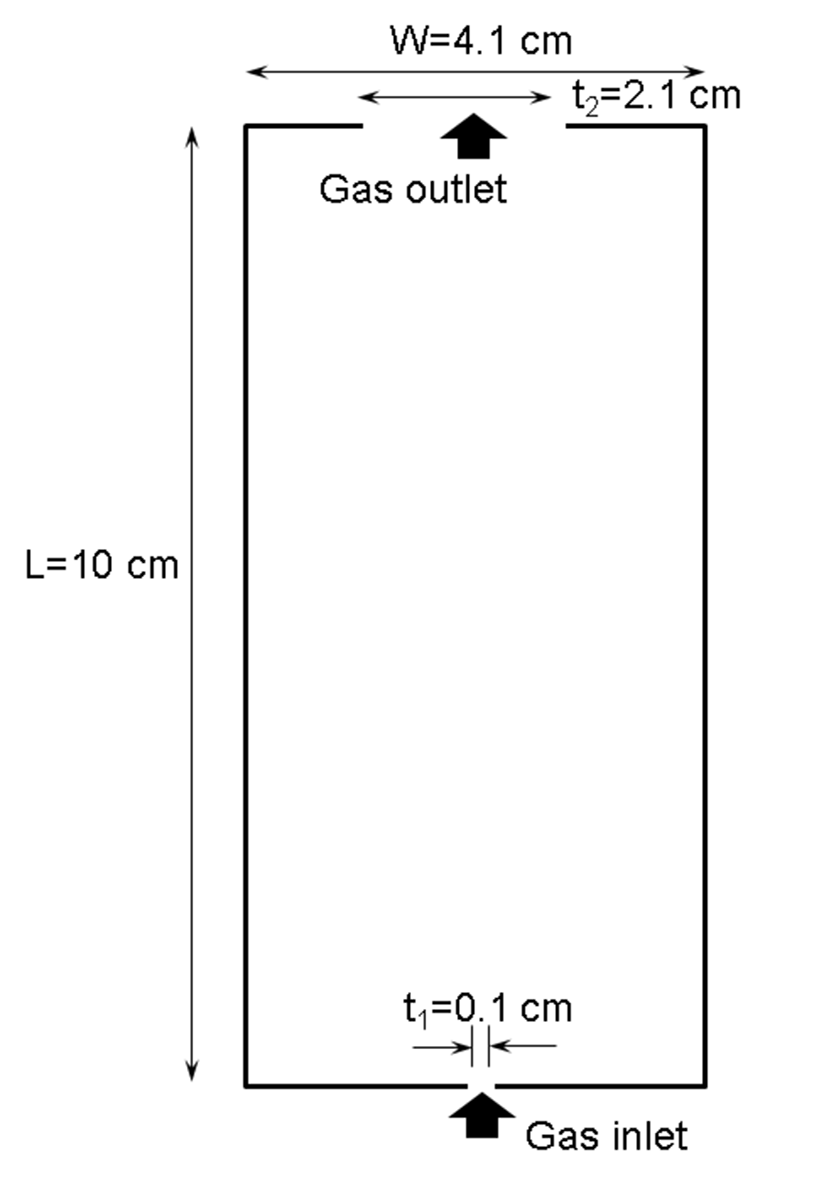

Figure 4: Two-dimensional rectangular jet cup with bottom gas inlet.

Table 2: Simulation Parameters

| Model Parameter | Suggested Value |
| --- | --- |
| Gas Viscosity (*µg*) | 1.8×10-11 MPa·s |
| Gas Molecular Weight | 29 g/mol |
| Temperature (*Tg*) | 300 K |
| Particle Density (*ρp*) | 0.4 g/cm3 |
| Fracture Toughness (*Kc*) | 3.0 MPa*·*cm1*/*2 |
| Hardness (*H*) | 290 MPa |
| Non-Dimensional Abrasive Wear Coefficient (*αa*) | 4.3×10-4 |
| Non-Dimensional Abrasive Wear Coefficient (*αe*) | 4.3×10-4 |
| Threshold Velocity (*u*0) | 12 m/s |
| Normal Collision Spring Constant (*kn*) | 1.0×105 N/cm |
| Tangential Spring Constant (*kt*) | 1.0×105 N/cm |
| Friction Coefficient (*µs*) | 0.1 |
| Restitution Coefficient (*e*) | 0.2 |
| Damping Coefficient Factor (*ηt/ηn*) | 0.5 |

**Note:** A constant *u*0 was adopted in this example for computational convenience, which ensures that collision events with impact velocities below *u*0 in the simulations do not produce any erosive wear. To reflect the particle-size dependency of the material strength, a step-wise approximation treatment was adopted, where a limiting particle diameter of 0.01 cm is prescribed to numerically prevent any further breakage of particles smaller.

It is recommended to use the Distributed-Memory Parallel (DMP) option in MFIX. The included *mfix.dat* file is set to execute the simulation on eight processors. To run the simulation, copy the *mfix.exe* file into the same directory as the *mfix.dat* and *particle input.dat* files and then type:

mpirun -np 8 ./mfix.exe > mfix.out 2>&1

This executes the code and put the model output, standard output, and standard error messages into the file *mfix.out.*

1. Conclusion and Discussion

As the current attrition model acts as a post-processer of the computational results from the existing MFIX-DEM Module, its numerical validity depends on the accuracy of the embedded CDM and DEM solution algorithms that have been extensively examined in previous studies [Garg et al., 2012b, Li et al., 2012]. With further continuing efforts on model calibration and validation, the present framework is expected to extend additional predictive dimensions to CCSI on sorbent material selection and lifetime estimation, which greatly contributes to the future development, design, and optimization of the carbon capture materials and systems.

It should also be noted that in the current numerical studies, material properties are assumed to be constant. However, in reality, it is possible that material properties can significantly vary with changes of environmental conditions such as temperature, chemical composition of the gas phase, and particle shapes/dimensions. Such effects need to be considered. Although the DEM Method is able to describe the particle interactions in high resolution, its application to large systems and solids loading inventory is limited by the extremely expensive computational costs, requiring the accommodation of further upscaling schemes and methodologies.

1. Acknowledgment

Pacific Northwest National Laboratory is operated by the Battelle Memorial Institute for the US DOE under Contract No. DE-AC05-76RL01830. Los Alamos National Laboratory is operated by Los Alamos National Security, LLC, for the US DOE under Contract No. DE-AC52-06NA25396. This work was funded by the U.S. Department of Energy Office of Fossil Energy’s Carbon Capture Simulation Initiative led by the National Energy Technology Laboratory.

1. Example Input File

#

# Simulate a rectangular jet cup

#

# Run-control section

# -----------------------------

RUN_NAME = 'attrn_jetcup_box'

DESCRIPTION = '2D jet cup with bottom inlet'

RUN_TYPE = 'new'

UNITS = 'cgs'

TIME = 0.0

TSTOP = 0.01

DT_MIN = 1e-7

DT = 1.0e-5

DT_MAX = 1E-4

MAX_INLET_VEL_FAC = 100.d0

NORM_g = 0.0

ENERGY_EQ = .FALSE. !do not solve energy eq

SPECIES_EQ = .FALSE. .FALSE.

MOMENTUM_X_EQ(1) = .FALSE.

MOMENTUM_Y_EQ(1) = .FALSE.

MOMENTUM_Z_EQ(1) = .FALSE.

DRAG_TYPE = 'WEN_YU'

GRAVITY = 980.0

# Geometry Section

# -----------------------------

COORDINATES = 'cartesian'

XLENGTH = 4.1 !length

IMAX = 41

YLENGTH = 10.0

JMAX = 50

NO_K = .TRUE.

DZ(1) = 0.04

# Numeric

# -----------------------------

MAX_NIT = 250

DISCRETIZE = 9*2

DEF_COR = .T.

LEQ_IT = 9*200

LEQ_TOL = 9*1.0E-6

TOL_RESID = 1.0E-3

LEQ_SWEEP = 9*'ISIS'

! Norm_g = 0.0

! LEQ_IT(1) = 40

# Gas-phase Section

# -----------------------------

! RO_g0 = 1.20e-3

MU_g0 = 1.8E-4

MW_avg = 29

# Solids-phase Section

# -----------------------------

MMAX = 1

RO_s = 0.4

D_p0 = 0.04

! e must be defined, even in DEM simulations where it is not used

e = 0.9

! phi must be set if MMAX >0, however, it is only used if schaeffer

! or friction models are invoked

Phi = 0.0

EP_star = 0.20

# Initial Conditions Section

# -----------------------------

! section 1

IC_X_w(1) = 0.0

IC_X_e(1) = 4.1

IC_Y_s(1) = 0.0

IC_Y_n(1) = 10.0

IC_EP_g(1) = 1.0

IC_U_g(1) = 0.0

IC_V_g(1) = 10.0

IC_U_s(1,1) = 0.0

IC_V_s(1,1) = 0.0

IC_T_g(1) = 300.0

IC_P_g(1) = 1.0D6

# Specify boundary conditions

! BC are not necessary for pure DEM simulations as particles see all

! boundaries as walls unless the boundary is a DEM inlet/outlet (which

! is defined later). BC are needed for coupled simulations to define

! fluid interaction.

#--------------------------------

! Inlet and outlet

! inlet1

BC_X_w(1) = 2.0

BC_X_e(1) = 2.1

BC_Y_s(1) = 0.0

BC_Y_n(1) = 0.0

BC_TYPE(1)= 'MI'

BC_EP_g(1) = 1.0

BC_U_g(1) = 0.0

BC_V_g(1) = 15000.0

BC_P_g(1) = 1.0D6

BC_T_g(1) = 300.0

! outlet

BC_X_w(2) = 1.0

BC_X_e(2) = 3.1

BC_Y_s(2) = 10.0

BC_Y_n(2) = 10.0

BC_TYPE(2)= 'PO'

BC_P_g(2) = 1.0D6

BC_T_g(2) = 300.0

# Output Control

# -----------------------------

RES_DT = 0.01 ! interval at which restart (.RES) file is updated

OUT_DT = 1. ! interval at which standard output (.OUT) file is updated

NLOG = 25 ! interval in no. of time steps at which (.LOG) file is written

! Interval at which .SPX files are written

SPX_DT(1) = 0.01 ! Void fraction (EP_g)

SPX_DT(2) = 0.1 ! Gas and solids pressure (P_g, P_star)

SPX_DT(3) = 0.1 ! Gas velocity (U_g, V_g, W_g)

SPX_DT(4) = 0.1 ! Solids velocity (U_s, V_s, W_s)

SPX_DT(5) = 100.0 ! Solids density (ROP_s)

SPX_DT(6) = 100.0 ! Gas and solids temp. (T_g, T_s1, T_s2)

SPX_DT(7) = 100.0 ! Gas and solids mass fractions (X_g, X_s)

SPX_DT(8) = 100.0 ! Granular Temperature (G)

SPX_DT(9) = 100.0 ! User defined scalars

FULL_LOG = .TRUE. ! display residuals on screen

RESID_STRING = 'P0' 'U0' 'V0' ! which residuals to display

# DMP control

# -----------------------------

NODESI = 8

NODESJ = 1

NODESK = 1

# DES

# -----------------------------

DISCRETE_ELEMENT = .TRUE.

DES_CONTINUUM_COUPLED = .T.

DES_INTERP_ON = .T.

WALLDTSPLIT = .T.

NFACTOR = 2000

DIMN = 2

! GENER_PART_CONFIG = .T.

! DES_EPS_XSTART = 3.8

! DES_EPS_YSTART = 30.0

! VOL_FRAC(1) = 0.01

PARTICLES_FACTOR = 10

PARTICLES = 8000

DES_NEIGHBOR_SEARCH = 4

NEIGHBOR_SEARCH_N = 20

MN = 20 ! Maximum number of neighbors allowed per particle [20]

KN = 1.0D6 ! Normal inter-particle collision spring constant

KT_FAC = @(2.0/7.0) ! Tangential spring factor = KT/KN [2/7]

KN_W = 1.0D6 ! Normal particle-wall collision spring constant

KT_W_FAC = @(2.0/7.0) ! Tangential spring factor = KT_W/KN_W [2/7]

MEW = 0.1 ! Inter-particle friction coeffienct

MEW_W = 0.1 ! Particle-wall friction coefficient

! set the particle-particle restitution coefficient in an array arranged as

DES_EN_INPUT = 0.2

! particle-wall rest coef arranged in array arranged as

DES_EN_WALL_INPUT = 0.2 !particle-wall rest coef

DES_ETAT_FAC = @(1/2) ! damping coefficient factor = ETAT/ETAN [1/2]

DES_ETAT_W_FAC = @(1/2) ! damping coefficient factor = ETAT_W/ETAN_W [1/2]

PRINT_DES_DATA = .TRUE. ! write DEM data : *.vtp files

DES_RES_DT = 0.01

DES_SPX_DT = 0.01 ! interval to write *.vtp files in pure DEM simulation

# Attrition

# -----------------------------

DES_Attrition = .T.

FractureHardness = 2.9D9 !NaCl property in Ghadiri and Zhang

FractureToughness = 3.0D7 !NaCl property in Ghadiri and Zhang

DESAlpha = 4.3D-4 !NaCl property in Ghadiri and Zhang

ABRAlpha = 4.3D-7 !Assumed to be 1E-3 of chipping coefficient

DESAttritionThresh = 1200.0

1. References

Archard, J.F., “Contact and Rubbing of Flat Surfaces,” *Journal of Applied Physics*, 24: 981–988, 1953.

Bemrose, C.R., and Bridgwater, J., “A Review of Attrition and Attrition Test Methods,” *Powder Technology*, 49:97–126, 1987.

Bentham, A.C., Kwan, C.C., Boerefin, R., and Ghadiri, M., “Fluidized-Bed Jet Milling of Pharmaceutical Powders,” *Powder Technology*, 141:233–238, 2004.

Cundall, P.A., and Strack, O.D.L., “The Distinct Element Method as a Tool for Research in Granular Media,” Technical Report NSF Grant ENG76-20711, National Science Foundation, 1978.

Garg, R., Galvin, J., Li, T., and Pannala, S., “Documentation of Open-Source MFIX- DEM Software for Gas-Solids Flows,” 2012a.

Garg, R., Galvin, J., Li, T., and Pannala, S., “Open-Source MFIX-DEM Software for Gas-Solids Flows, Part i: -Verification Studies,” *Powder Technology*, 220:122–137, 2012b.

Ghadiri, M., and Zhang, Z., “Impact Attrition of Particulate Solids, Part 1: A Theoretical Model of Chipping,” *Chemical Engineering Science*, 57:3659–3669, 2002.

Gidaspow, D., “Multiphase Flow and Fluidization-Continuum and Kinetic Theory Descriptions,” Academic Press, 1994.

Hutchings, I.M., “Transitions, Threshold Effects and Erosion Maps,” in Ritter, J.E., editor, *Key Engineering Materials*, volume 71, p. 75–92, Trans Tech Publications, 1992.

Hutchings, I.M., “Mechanisms of Wear in Powder Technology: A Review,” *Powder Technology*, 76:3–13, 1993.

Johnson, G., Massoudi, M., and Rajagopal, K.R., “A Review of Interaction Mechanisms in   
Fluid-Solid Flow,” Technical Report DOE/PETC/TR-90/9, Department of Energy, 1990.

Jørgensen, K., Bach, P., and Jensen, A.D., “Impact and Attrition Shear Breakage of Enzyme Granules and Placebo Particles-Application to Particle Design and Formulation,” *Powder Technology*, 149:157–167, 2005.

Li, T., Garg, R., Galvin, J., and Pannala, S., “Open-Source MFIX-DEM Software for Gas-Solids Flows, Part ii: Validation Studies,” *Powder Technology*, 220:138–150, 2012.

Li, Y., Zhang, J., and Fan, L., “Discrete-Phase Simulation of Single Bubble Rise Behavior at Elevated Pressures in a Bubble Column,” *Chemical Engineering Science*, 55:4597– 4609, 2000.

Pougatch, K., Salcudean, M., and McMillan, J., “Simulation of Particle Attrition by Supersonic Gas Jets in Fluidized Beds,” *Chemical Engineering Science*, 65:4829–4843, 2010.

Sanyal, J., Marchisio, D.L., Fox, R.O., and Dhanasekharan, K., “On the Comparison Between Population Balance Models for CFD Simulation of Bubble Columns,” *Industrial & Engineering Chemistry Research*, 44:5063–5072, 2005.

Syamlal, M., Rogers, W., and O’Brien, T.J., “MFIX Documentation,” Technical Report   
DOE/METC-95/1013, NTIS/DE95000031, National Energy Technology Laboratory, Department of Energy, 1993.

Tsuji, Y., Kawaguchi, T., and Tanaka, T., “Discrete Particle Simulation of Two- Dimensional Fluidized Bed,” *Powder Technology*, 77:79–87, 1993.

van der Hoef, M.A., Ye, M., van Sint Annaland, M., Andrews, IV, A.T., Sundaresan, S., and Kuipers, J.A.M., “Multiscale Modeling of Gas-Fluidized Beds,” *Advances in Chemical Engineering*,   
p. 65–149, 2006.

Werther, J., and Xi, W., “Jet Attrition of Catalyst Particles in Gas Fluidized Beds,” *Powder Technology*, 76:39–46, 1993.

Yuregir, K.R., Ghadiri, M., and Clift, R., “Impact Attrition of Sodium Chloride Crystals,” *Chemical Engineering Science*, 42(4):843–853, 1987.

MFIX-DEM Pulverization Model

1. Installation

The installation of the Coal Pulverization Discrete Element Model (DEM) generally follows the Multiphase Flow with Interphase eXchanges (MFIX) manual [1]. The present document solely intends to provide an overview on specific procedures required to enable the Pulverization-DEM module within MFIX. Please refer to the MFIX User Manual [1] for additional details.   
Note: The current Pulverization-DEM module only works with the MFIX-2012-1 version.

* 1. Prerequisites

The same hardware and software environments that are specified by MFIX [1] apply.

* 1. Third Party Software

The open-source, multi-platform data analysis and visualization application *ParaView* is recommend for post-processing of the MFIX simulation and can be downloaded online at: [http://www.paraview.org](http://www.paraview.org/). Other similar visualization software (for example, *Tecplot*®, *VisIt*) can also serve the same purpose.

* 1. Product Installation

It is assumed that the user has downloaded the MFIX source files and created the entire MFIX directory (for example, $HOME/mfix) in the Linux® system. Currently, the Intel® Fortran compiler is recommended to be used for the installation.

The source codes and the simulation input files for the Pulverization-DEM model are distributed as a tar ball Pulverization.tar.gz. Download the tar ball into the MFIX directory, and then extract the tar ball into a run folder $HOME/mfix/pulverization by typing:

tar xvf Pulverization.tar.gz

Three subdirectories are created: model contains the Pulverization-DEM module files, test contains the example input files, and results contain the standard output files.

Copy all of the contents within the $HOME/mfix/pulverization/model folder into the $HOME/mfix/pulverization folder by typing:

cp –r $HOME/mfix/pulverization/model/* $HOME/mfix/pulverization/

Move the following files from the $HOME/mfix/pulverization folder to the $HOME/mfix/model folder to replace the original files:

mfix_l.make

mfix_l_not.make

mfix_u.make

mfix_u_not.make

Copy the desnamelist.inc and calc_attrition_des.f files from the $HOME/mfix/pulverization/des folder to the $HOME/mfix/model/des folder by typing:

mv –f mfix_l.make mfix_l_not.make mfix_u.make mfix_u_not.make $HOME/mfix/model

cd $HOME/mfix/pulverization/des

cp –f desnamelist.inc calc_attrition_des.f $HOME/mfix/model/des

cd ..

Follow the MFIX instructions [1] to build the mfix executable in the $HOME/mfix/pulverization folder.

sh $HOME/mfix/model/make_mfix

Select “Yes” for “Force re-compilation of source files in run directory”. Upon a successful build, a custom mfix.exe is available in the $Home/mfix/pulverization folder.

1. Simulations

The Pulverization-DEM model input files mfix.dat and particle_input.dat are included in the $Home/mfix/pulverization/test folder, where a 2D spherical coal with a diameter ~0.2 cm is represented by assemblies of discrete elements with a uniform diameter of ~75 μm, and is subjected to vertical compression from a rigid plate resembled by a horizontal array of pseudo particles.   
**Note: The present model is currently limited to serial computation.**

Simulation results can be viewed in ParaView by loading the .pvd file and then applying the “Glyph” filter where the “Glyph Type” should be changed to “Sphere”, “Orient” selected, “Scale Mode” should be changed to “scalar”, and the “Set Scale Factor” is suggested to be “1”. The damage evolution within the coal can be visualized by changing the legend from “Diameter” to “Fcohesive”, which indicates whether a particle is bonded (Fcohesive=1) or not bonded (Fcohesive=0).

The transient load response is recorded in the output file “Monitor_Stress.dat”, in which the first column corresponds to the time, the second column corresponds to the tangential force, and the third column is the normal force. A time-load plot can be obtained as pictured in Figure 5:

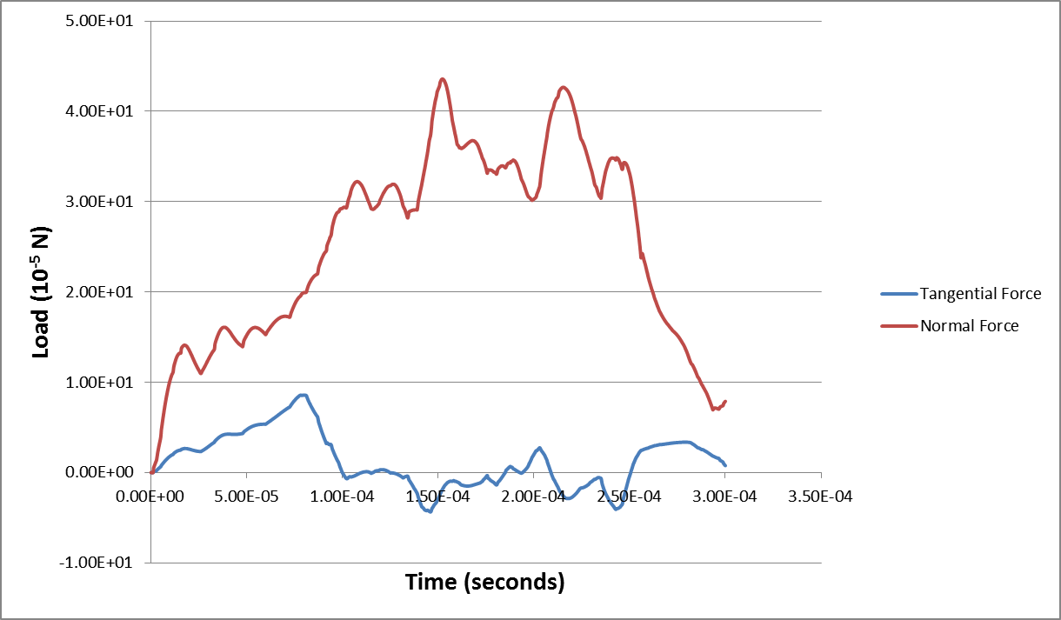

Figure 5: Transient load response (Intel Fortran compiler used).

The standard output results are contained in the $Home/mfix/pulverization/results folder.

1. References

[1] MFIX – Multiphase Flow with Interphase eXchanges, Version MFIX-2012-1, January 2012.   
(The readme.pdf is distributed within the MFIX tar ball.)

Solvents

Simulating Liquid Film Flow over an Inclined Plate

1. Introduction

This document describes the simulation setup for studying liquid film flow over an inclined plate. Film flow over an inclined plate was numerically investigated using the volume of fluid (VOF) multiphase method. Flow simulations were systematically carried out for a wide range of parameters, such as varying inlet cross section, flow rate, plate inclination angle, range of solvent properties, and contact angles. Based on results of rigorous and extensive simulations, scaling theory was proposed for interfacial and wetted areas and film thickness. For more details on the background, theory, problem definition and setup, and results, please see the corresponding report available within the CFD Product bundle of which this User Manual is included.

1. Fluent Simulation Case Study
   1. Basic Problem Description

In this user manual, film flow over an inclined plate is simulated using the commercial CFD code Ansys Fluent 14.0 [1] installed on NETL’s cluster SBEUC. The wetting behavior is then examined by post processing of the simulation results. A schematic of the simulation setup is presented in Figure 6. The domain consists of a stainless steel smooth plate with dimensions 60 mm long by 50 mm wide, and inclined at an angle of 60° with respect to the horizontal. The depth of the domain was taken as 7 mm. These are 3D gas-liquid two-phase flow simulations. In the default setting, the gas phase is defined as stagnant air at 25°C (density ρ = 1.185 kg/m3, viscosity µ = 1.831×10-5 Pa-s). The properties of the gas may be modified according to one’s requirement; however, the gas should not be made to flow without additional considerations that are not accounted for in the presented case studies. In the default setting, the liquid phase is defined as water at 25°C (ρ = 997.0 kg/m3, µ = 0.89×10-4 Pa-s). A default setting for the water flow rate is also provided, and the value depends on the particular case in question. However, the properties *and* flow of the liquid phase may be varied according to one’s needs. Regardless, the liquid phase enters the domain at the top and exits the bottom due to the presence of gravity. For further details on the computational setup and numerical formulation, the user is referred to the accompanying report.

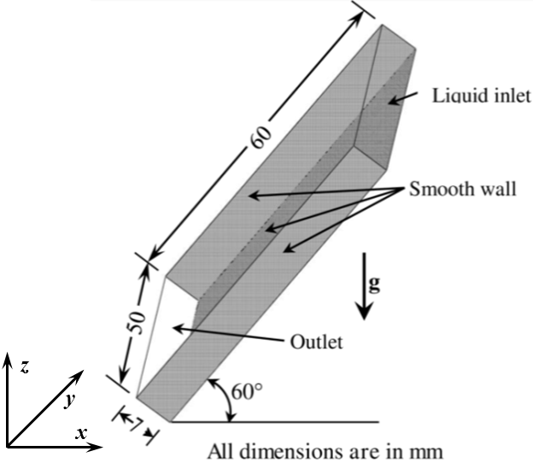

Figure 6: Schematic of the computational flow domain –  
liquid flows down from top of the inclined smooth plate.

* 1. Simulation Overview and Prerequisites

The hardware and software requirements follow that for Fluent. Since these simulations are extremely computationally intense due to the fine grid and small time steps required, all of these simulations were run in parallel on a high performance computing (HPC) system. The user is advised to contact their system administrator for an appropriate script file for running an interactive parallel Fluent job on their system.

The computational flow domain was modeled and discretized in GAMBIT, a preprocessor tool of Fluent. Proper meshing is a critical step in simulation to achieve converged and accurate results. In this context, the number of meshes in the domain was varied with 1.26-1.50M, depending on the case. The simulations were initially run on 32 cores with a time step of seconds. However, these simulations tended to diverge, indicating smaller time steps were needed. Ultimately, a typical case took around 96 hours wall time to complete.

The availability of 9 ANSYS HPC packs and 384 dedicated cores allowed for a wide ranging parametric investigation. Specifically, these resources permitted 3 cases to be run simultaneously with each parallel simulation using 128 cores. More than 250 simulations, involving different solvent properties and configurations, were run. Several new insights in the field of film flow have been achieved using the results from this investigation.

Ansys Fluent also has its own data visualization and post-processing capabilities, which is demonstrated in this manual. However, Tecplot and Ensight may also be used for post processing of the results and data visualization. Tecplot has enriched user control capabilities for CFD post processing and plot presentation. Both software packages enable excellent post processing and analysis of the simulation results and presentation of flow visualization. Regardless, users can choose other software tools for their post-processing needs.

* 1. Simulation Setup

It is assumed that users have access to Fluent on their chosen platform and know how to launch an interactive parallel Fluent session. This section briefly describes steps to run a Fluent simulation for liquid flow down an inclined plate given the appropriate Fluent case file. The case file contains the problem definition, including meshing scheme of the domain, boundary conditions, solver setting, discretization methods, and convergence criteria. The necessary case file for building the basic Fluent simulation for either rivulet flow (rivulet.cas) or for full film flow (film.cas) down an inclined plate are available in the CFD Product bundle of which this User Manual is included.

Once the user has submitted their job script, Fluent starts interactively and a new window displays on the desktop. Details can be found in the Ansys Fluent user manual; however, a snapshot of the GUI is shown below for instructive purposes. In addition to the Menu bar, the GUI is comprised of the four indicated components: navigation panel, task page, graphic window, and console (Figure 7). These terms are used in the following instructions.



Figure 7: GUI components.

The following tutorial walks the user through setting up and running a Fluent simulation assuming the rivulet flow case. The rivulet.cas file that is downloaded as part of the CFD Product bundle, of which this User Manual is included, should be placed into the working directory. This process consists of 13 steps that primarily deal with moving through each item in the navigation panel (see above) for this case. Following this procedure and that on post processing (following section), a user is able to compute the film thickness, interfacial, and wetted areas for any solvents at any flow rates (laminar flow regime).

1. **Reading the Case File**

The case file should be read from the **Menu** bar as:

File → Read → Case

* 1. A new dialog box displays as shown in Figure 8. Select the supplied case file (rivulet.cas).
  2. Click OK to read the file.

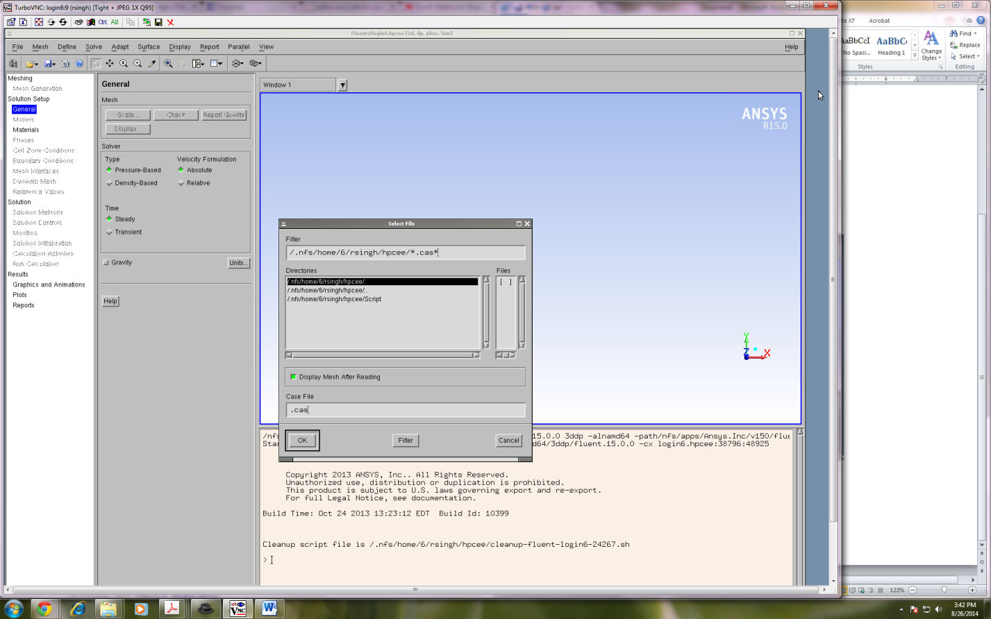

Figure 8: Dialog box for reading a case file (*.cas).

After reading, the mesh is displayed in the **Graphic window** (Figure 9):

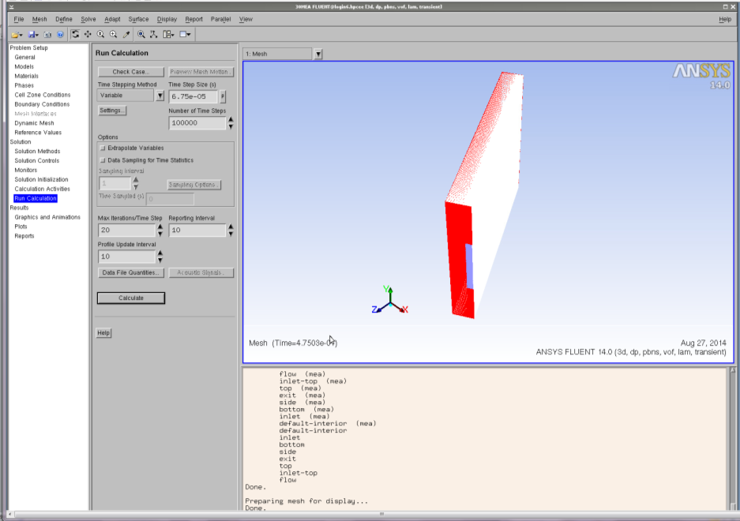

Figure 9: Graphic window with mesh displayed.

1. **General and Model**

No action is needed. All settings are already complete in the case file for conducting a basic volume of fluid simulation of film flow over an inclined plate. In this section, various general settings were made, including type of simulation (transient/steady), velocity formulation, gravitational effects, solver settings, etc.

1. **Material Properties**

Click **Materials** in the navigation panel and a list appears in the task page. Select the material, and a dialog box appears for defining the material (Figure 10). Here properties of the gas and solvent may be changed if desired.

Materials → Solvent → Create/Edit

* 1. Enter the name of the solvent.
  2. Enter the density.
  3. Enter the viscosity.
  4. Click Change/Create and then close the dialog box.

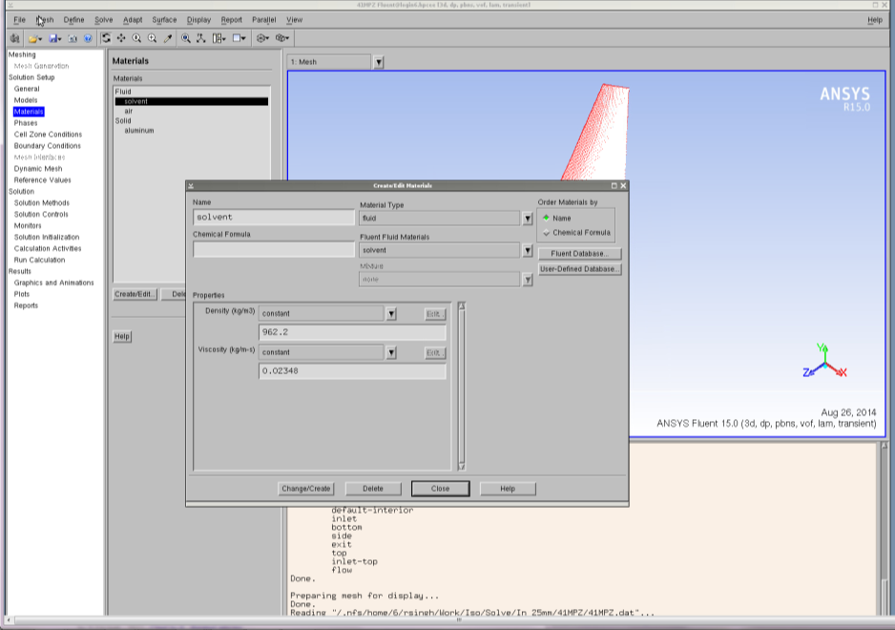

Figure 10: Materials window.

Materials → Gas → Create/Edit

1. Enter the density.
2. Enter the viscosity.
3. Click Change/Create and then close the dialog box.
4. **Phases**

Primary and secondary phases were already defined in the .cas file; however, the properties of the solvent and gas may have changed (Step 3). In this event, the surface tension for the interphase interaction should also be modified appropriately. To do this, click **Phases** in the navigation panel and a list of phases appear in the task page and an option for specifying the interaction. Click interaction and a dialog box appears (Figure 11).

Phases → Interaction

* 1. Click the Surface Tension tab.
  2. Select Constant from the Surface Tension drop-down and then enter the value of surface tension coefficient.
  3. Click OK to close the dialog box.

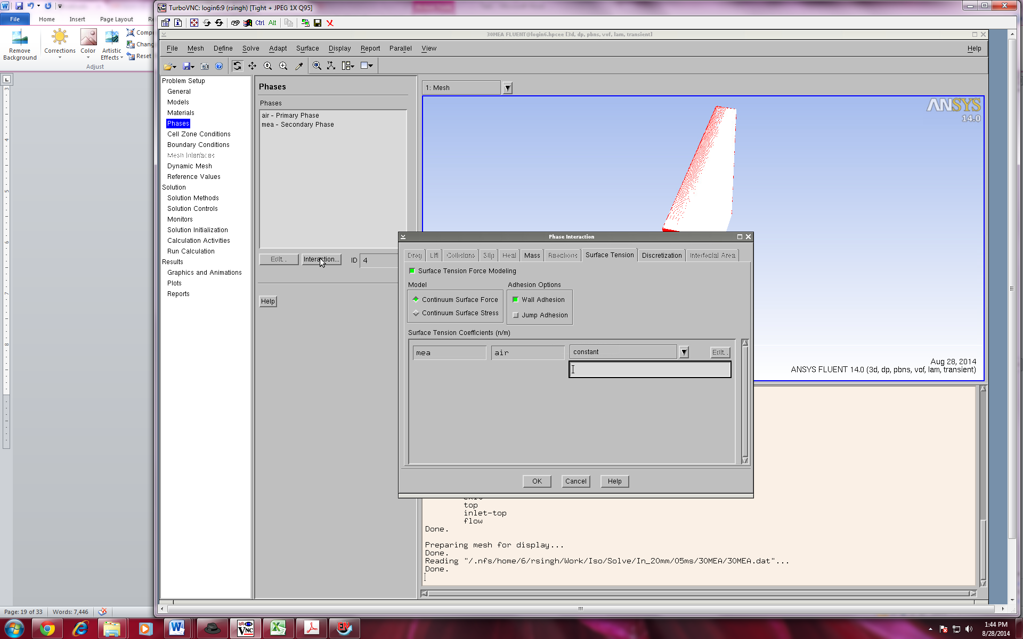

Figure 11: Phases window.

1. **Operating Conditions**

The operating conditions (temperature, density, and gravity) were already defined in the case file; however, the properties of the solvent and gas may have changed (Step 3). In this event, the operating density should be modified appropriately, in which the lowest value of the density among both phases should be specified as the operating density to assist in convergence. Click **Cell Zone Conditions** in the navigation panel and an option appears in the task page for the operating conditions (Figure 12). Here the user may modify the gravity and operating density.

Cell Zone Conditions → Operating Conditions

* 1. Gravity and specified operating density are already enabled, only operating density has to be changed.
  2. Specify the density of the gas as operating density.
  3. Click OK to close the dialog box.

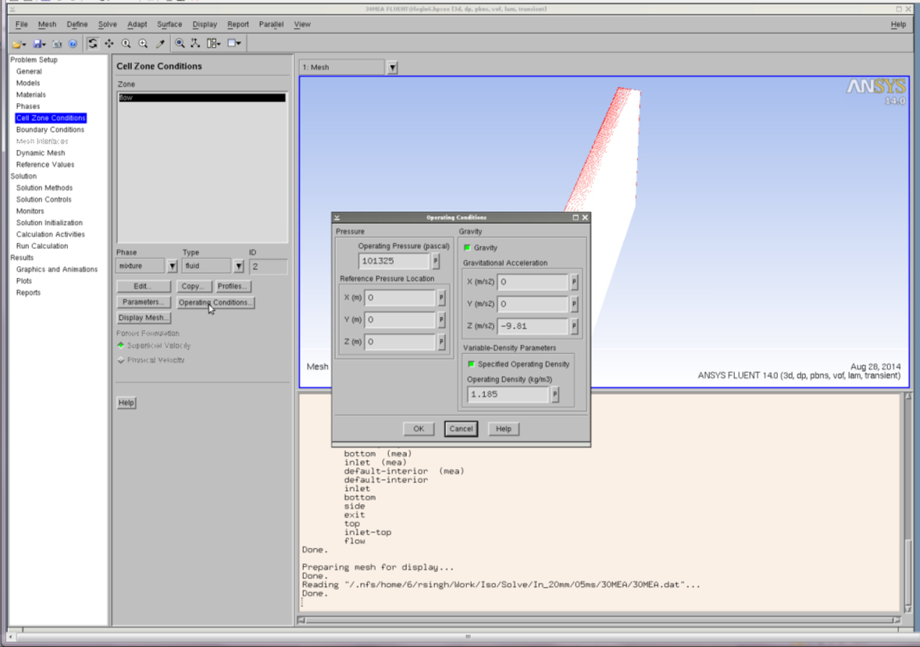

Figure 12: Cell Zone Conditions window.

1. **Boundary Conditions**

The boundary conditions were already defined in the case file; however, the user may adjust these accordingly. That is, the user has the option to change the value of the solvent inlet velocity, types of wall (no slip/slip), and contact angle of the solvent. The outlet boundary conditions should not be changed. Click **Boundary Conditions** in the navigation panel and a list of options appear in the task page for defining the boundary conditions (Figure 13). Here the user may modify the boundary conditions of the face associated with the wall and the inlet boundaries.

Boundary Condition → Bottom → Edit

* 1. Enter the contact angle for the wall adhesion.
  2. Select Constant in the drop-down for a static contact angle.
  3. Click OK to close the dialog box.

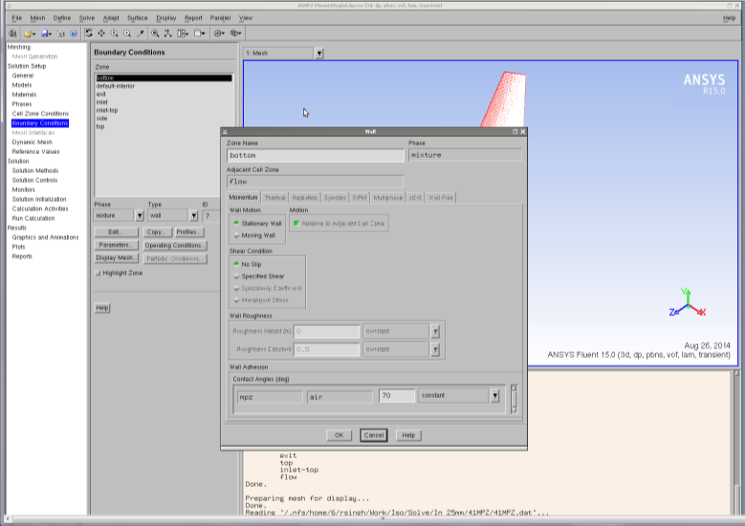

Figure 13: Boundary Conditions bottom window.

Boundary Condition → Side → Edit

1. Enter the contact angle for the wall adhesion.
2. Select Constant in the drop-down for a static contact angle.
3. Click OK to close the dialog box.

Boundary Condition → Inlet

1. Select Phase as mixture and then click the Edit button.
2. Specify the velocity magnitude in the dialog box (Figure 14).
3. Click OK to close the dialog box.

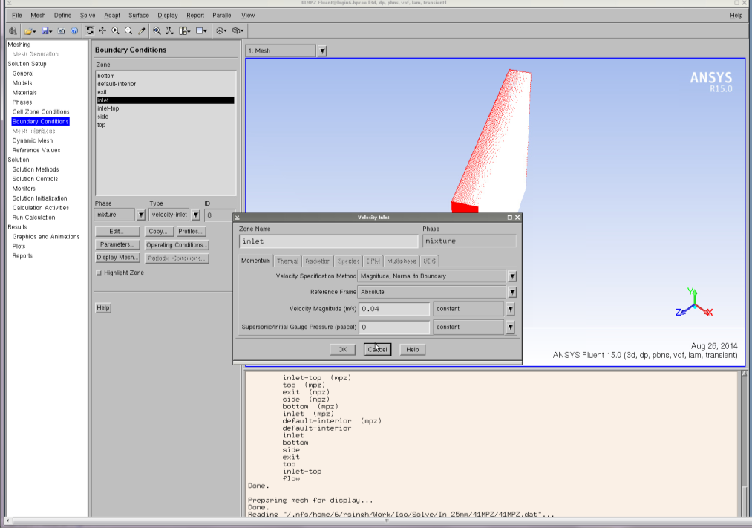

Figure 14: Boundary Conditions Inlet Mixture window.

Boundary Condition → Inlet

1. Select Phase as solvent and then click the Edit button.
2. Specify 1 in the Volume Fraction in the dialog box (Figure 15).
3. Click OK to close the dialog box.

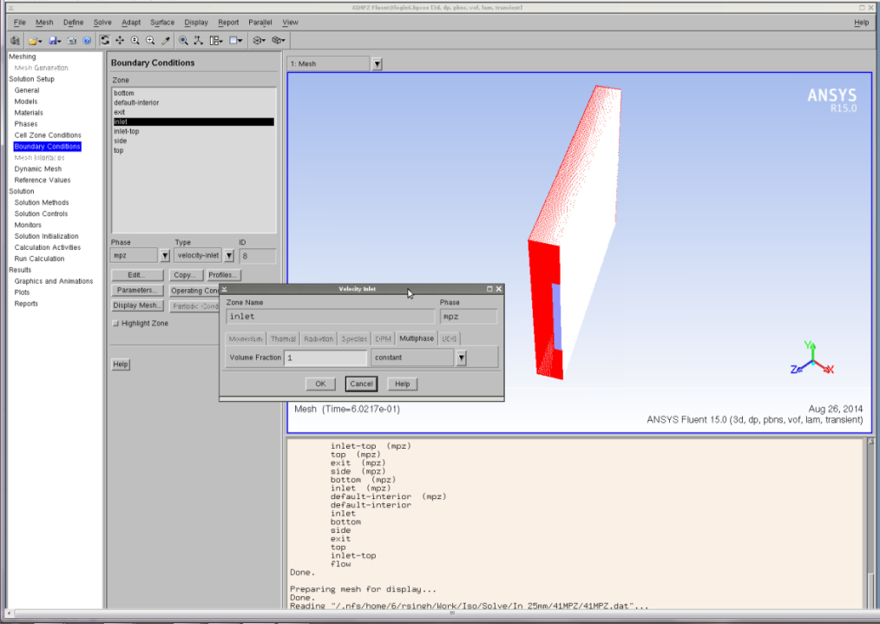

Figure 15: Boundary Conditions Inlet Solvent window.

1. **Solution Method and Solution Control**

No action is needed. All settings are already done in the case file. In this section, the spatial discretization scheme of all the transport equations, the transient formulation, and the   
pressure-velocity coupling were specified (Figure 16).

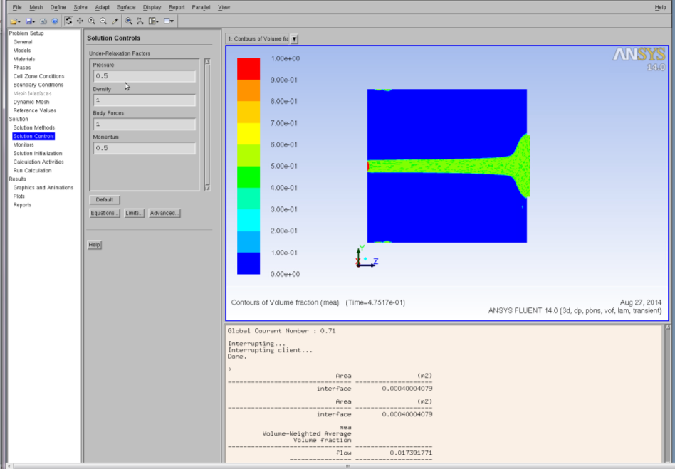

Figure 16: Solution Controls window.

1. **Solution Monitor**

All settings are already done in the case file; however, the user will need to change the directory path for each of the generated out files. In this section, monitoring of the convergence of the solutions by residual, mass flow rate, and wetted area were set up (Figure 17). In this study, a simulation is assumed to be converged when the mass flow at the exit and wetted area of the plate is constant.

* 1. Residual monitor is predefined. No action is needed.

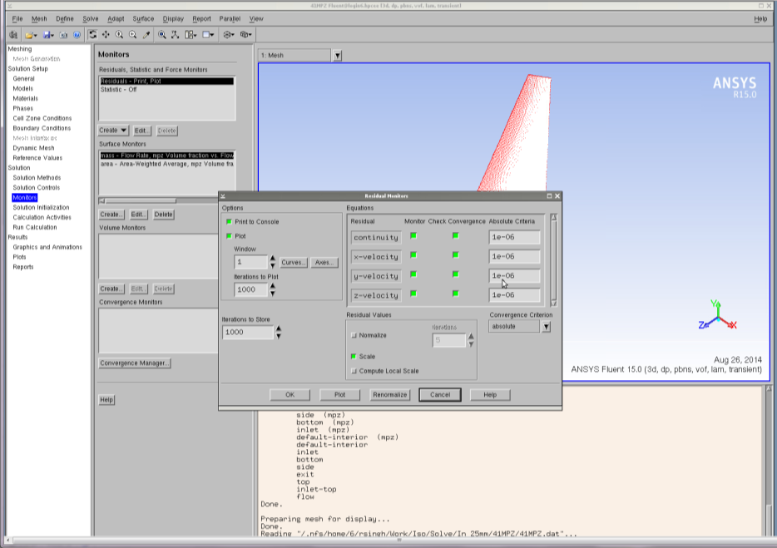

Figure 17: Residual Monitor window.

* 1. Surface monitor is predefined.

Here, a surface monitor is defined to track the solvent mass flow rate at the exit to ensure a converged solution. Change the directory path of the generated out file in the box higlighted by red in Figure 18. An additional surface monitor is also defined for the wetted area of the plate (Figure 18). As before, the directory path of the generated out file must be changed. When both quantities achieve steady value, the solution is considered to be converged.



Figure 18: Surface Monitor window.

* 1. Volume monitor is predefined.

This enables calculation for liquid holdup. Change the directory path for the generated out file.

1. **Initialize the Solution**

Click **Solution Initialization** in the navigation panel and an option for the initialization method displays. Select hybrid initialization and click initialize (Figure 19). Here the flow variables need to be defined so the flow field is initialized to these values.

Solution Initialize → Hybrid Initialization → Initialize

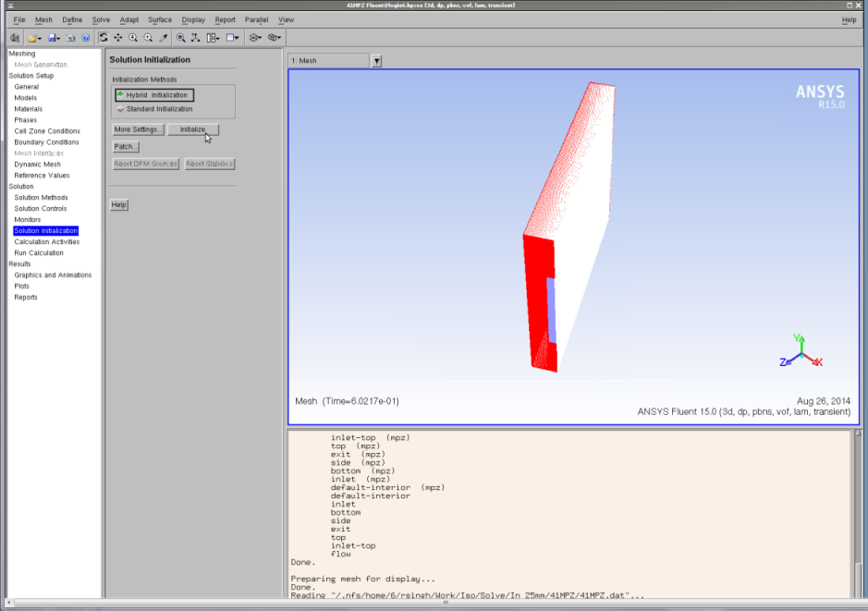

Figure 19: Solution Initialization Hybrid window.

1. **Patch the Domain**

In this section, the phase(s) that are present in the domain at the start of the simulation are specified. To define an initially dry plate, the user must specify air as the only phase present in the domain. Navigate to the **Menu** bar, select **Adapt**, and then a number of options appear in the drop-down. Select **Region** and a new dialog box appears (Figure 20).

Adapt → Region

* 1. Select the initial condition region by specifying the minimum and maximum coordinates of the flow domain; it is predefined in the case file.
  2. Click Mark button.
  3. Click Close to close the dialog box.

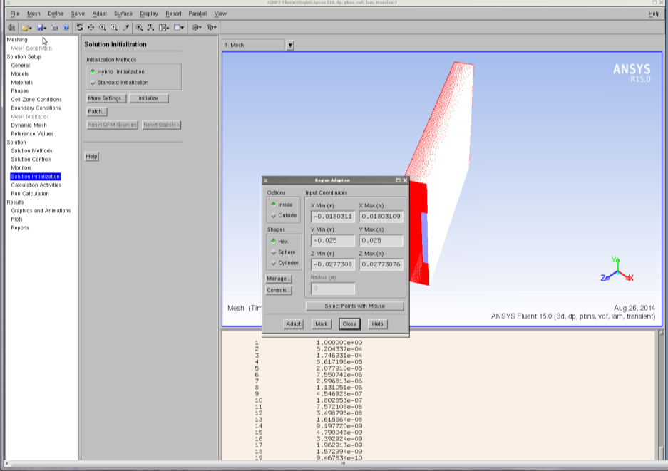

Figure 20: Solution Initialization Adapt Region window.

Solution Initialization → Patch

1. The Patch dialog box appears (Figure 21).
2. Scroll Phase drop-down and then select Solvent.
3. Select Volume Fraction.
4. Specify 0 in the Value (for initially dry plate).
5. Select the Register Patch.
6. Click Patch button.
7. Click Close button to close the dialog box.

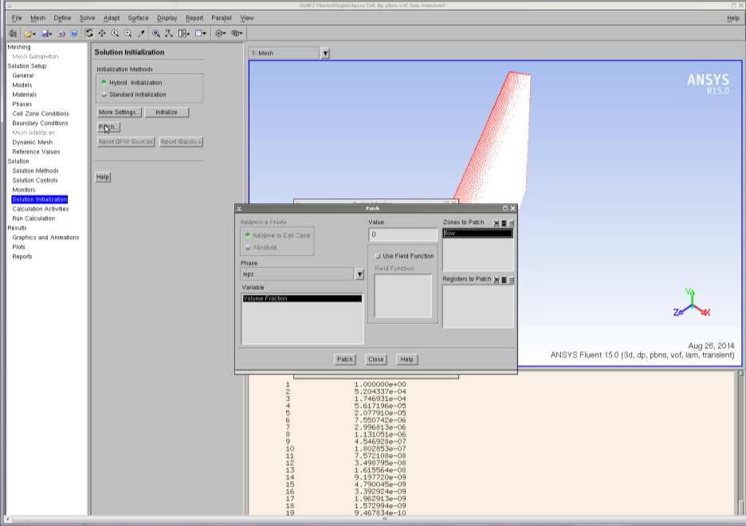

Figure 21: Solution Initialization Patch window.

1. **Autosave**

The autosave option saves the cas/data files automatically at a defined interval. If the job crashes, the user may restart the job with the latest saved file, otherwise, the simulation needs to be started from the beginning. The settings governing the autosave feature need to be set (Figure 22).

Calculation Activity → Autosave (Every) → Edit

* 1. Autosave dialog box displays.
  2. Enter number of time steps for auto save.
  3. Click each time.
  4. Click to retain only the most recent files. Specify the maximum number of data files.
  5. Specify the path and name of the file for autosave.
  6. Click OK to close the dialog box.

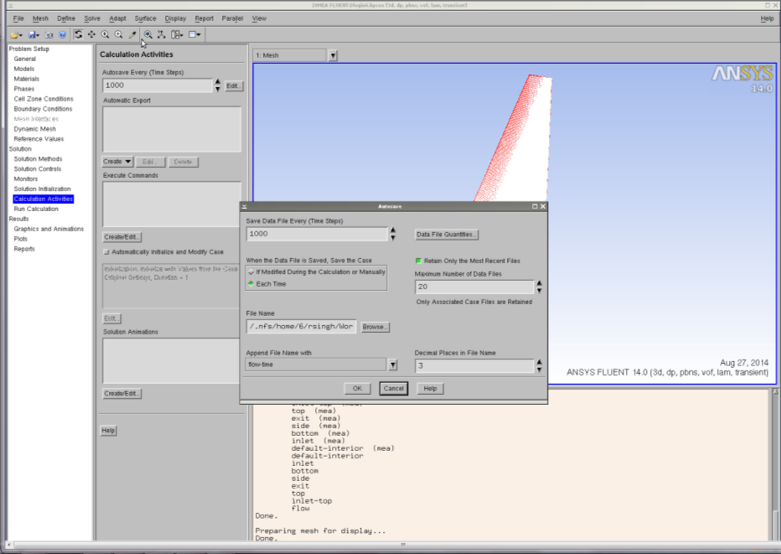

Figure 22: Autosave window.

1. **Starting the Simulation**

In this final step, the simulation is started. Click **Run Calculation** in the navigation panel and a list of run options appear in the task page (Figure 23). All quantities governing the time step have already been defined according to the case file, which uses a variable time stepping method. However, the interested user may modify these by clicking the options under Settings.

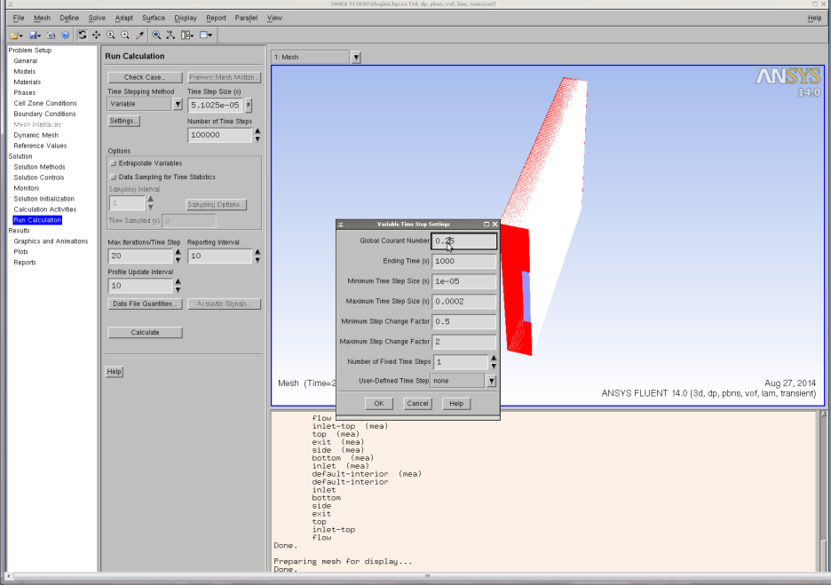

Figure 23: Run Calculation window.

Otherwise the final steps to running the simulation are as follows.

Run Calculation → Calculate

* 1. Specify the starting time step. After one time step, the time step size is automatically calculated.
  2. Specify the maximum iteration per time step.
  3. Specify the profile update interval.
  4. Specify the reporting interval.
  5. Click the button Calculate to start the simulation (Figure 24).
  6. Simulation starts.

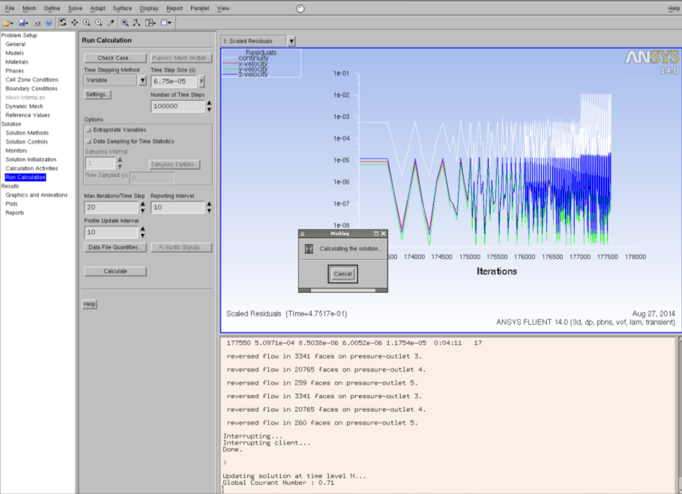

Figure 24: Run Calculation Calculate window.

Similarly, the surface monitor also appears in the graphic window. To look at the surface and volume monitor, scroll down the window drop-down and select the window for each monitor.

1. **Saving the Simulation**

The simulation is considered to be complete when the wetted area of the plate and mass flow rate of the solvent at the exit achieve steady value. Once the steady value is achieved, the simulation can be interrupted by clicking the **Cancel** button on the **working** dialog box in the graphic window. Once the simulation is interrupted, the following lines appear on the console:

Interrupting client…  
Done.

The case/dat file can now be saved for post processing and future use. From the **Menu** bar:

File → Write → Case & Data

A new dialog box displays.

* 1. Specify the name of Case/Data file box.
  2. Click OK button to save the Case/Data file.
  3. Simulation Post-Processing

Following successful launch and completion of the simulation, the users may examine any number of quantities, such as pressure or phase velocity. The user may also wish to calculate the film thickness, wetted area, area of the interface, and shape of the interface per scope of the problem. In the following section, the method to compute and plot these quantities is explained. Recall that in the VOF computation, a volume fraction of any phase of 0.50 represents the interface between phases.

1. **Tracking the Interface**

Navigate to the navigation panel, select **Graphics and Animations**, and then a number of options appear in the task page. From the task page select **Contours**.

Graphic and Animation → Contours → Set Up

The Contours dialog box displays (Figure 25).

* 1. Select Phase in the Contours drop-down.
  2. Select Solvent as phase drop-down.
  3. Activate the Clip to range option and uncheck the Auto range.
  4. Specify 0.5 as minimum and 1 as maximum value.
  5. Select Default Interior in the surface box.
  6. Click Display, and Contours appears in the graphic window.
  7. Click Close button to close the window.

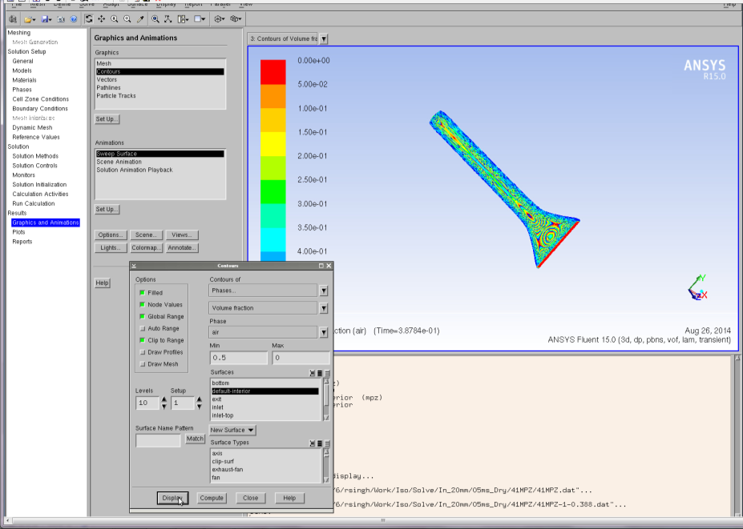

Figure 25: Graphics and Animations Contours window.

1. **Interface with Plate**

Navigate to the navigation panel, select **Graphics and Animations**, and then a number of options appear in the task page. From the task page select **Contours**.

Graphic and Animation → Contours

The Contour dialog box displays.

* 1. Select Phase in the Contours drop-down.
  2. Select Solvent as Phase drop-down.
  3. Activate the Clip to Range option.
  4. Specify 0.5 as minimum and 1 as maximum value.
  5. Activate the Draw Mesh.
  6. A new dialog box of mesh display opens (Figure 26).
  7. Select Bottom on the surface list.
  8. Click Display and mesh of the bottom displays.

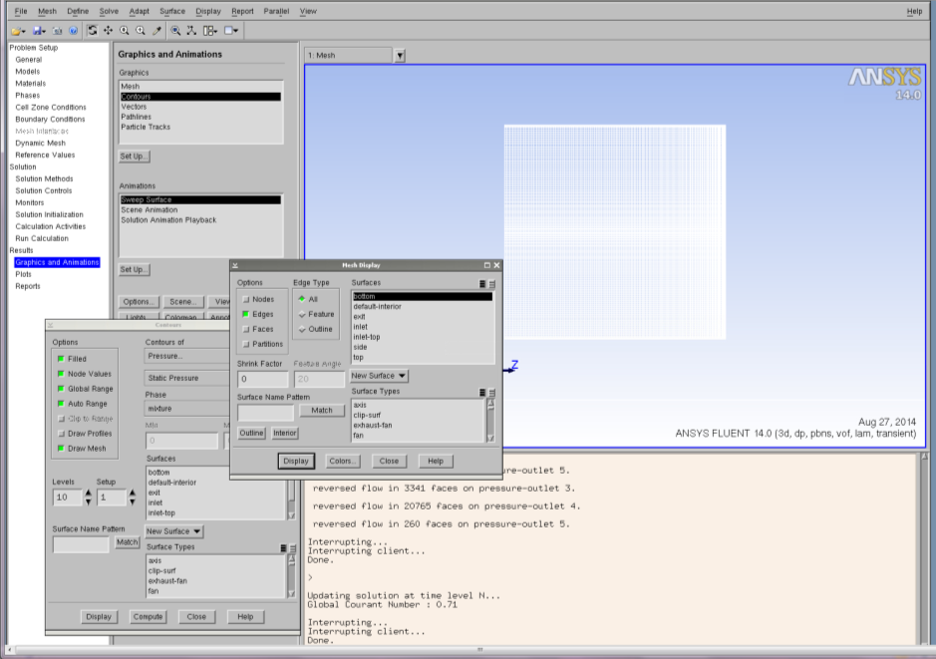

Figure 26: Graphics and Animations Contours Mesh Display window.

* 1. Click Close to close the window.
  2. Select Default Interior in the surface box.
  3. The Contour dialog box exists; click Display.
  4. Bottom wall and Contour appear in the graphic window (Figure 27).
  5. Click Close button to close the window.

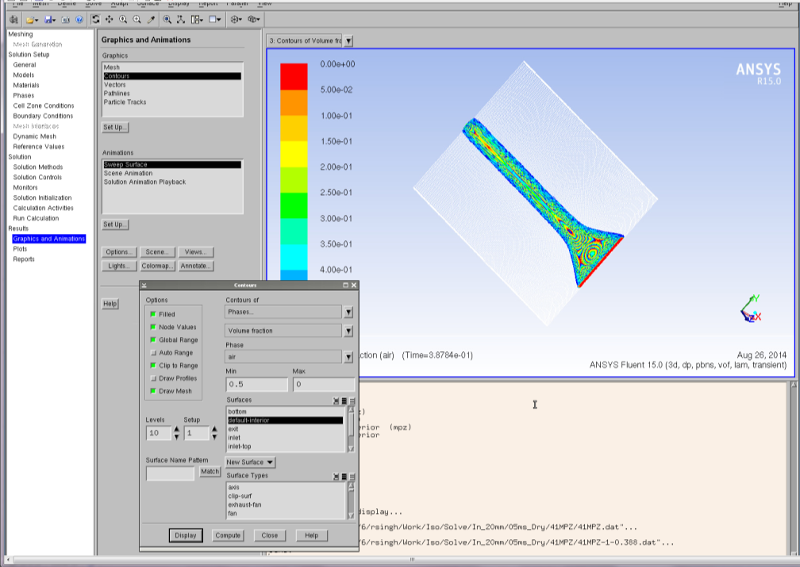

Figure 27: Graphics and Animations Bottom Wall and Contour window.

1. **Wetted Area of the Plate**

Navigate to the navigation panel, select **Graphics and Animations**, and then a number of options appear in the task page. From the task page select **Contours**.

Graphic and Animation → Contours

The Contour dialog box displays.

* 1. Select Phase in the Contours drop-down.
  2. Select Solvent as phase drop-down.
  3. Activate the Clip of Auto Ranges.
  4. Select Bottom in the surface box.
  5. Clear the Draw Mesh check box if already selected.
  6. Click Display, and Contours appears in the graphic window (Figure 28).
  7. Click Close button to close the window.

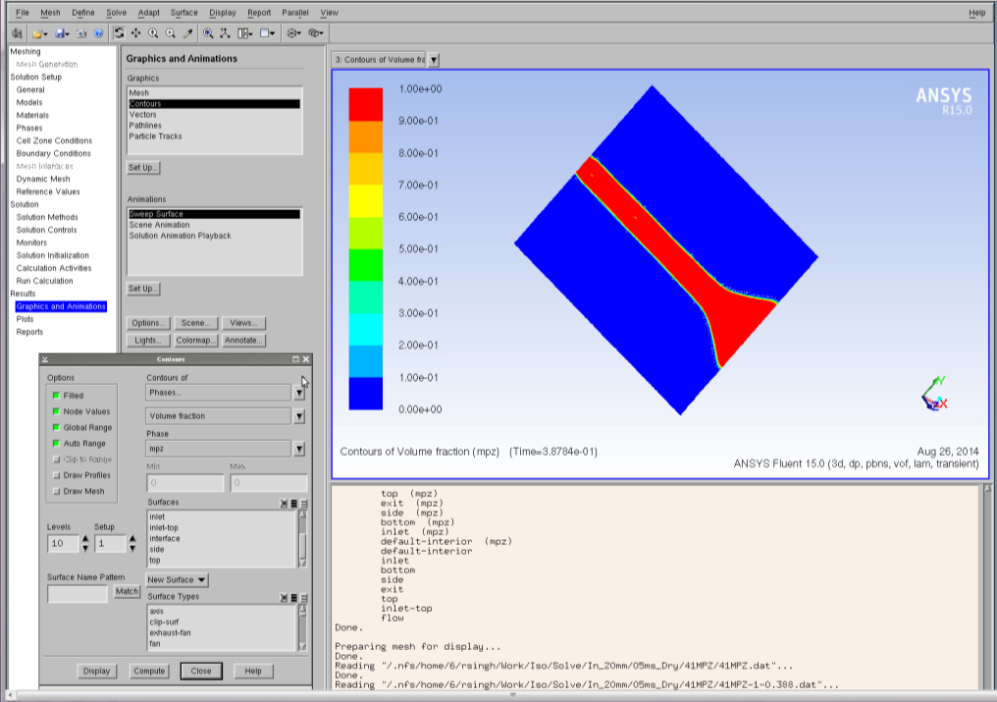

Figure 28: Graphics and Animations Contours Solvent window.

1. **Saving a Snapshot**

To save an image displayed in the graphic window for future use, navigate to the **Menu bar** and select **File**. A number of options appear in the drop-down. From the drop-down, select **Save Picture**, and a dialog box for saving the picture appears (Figure 29).

File → Save Picture

* 1. Select file format (ps/eps/png/jpeg/tiff).
  2. Select Save button.
  3. A new dialog box appears; write the file name.
  4. Close the dialog box.

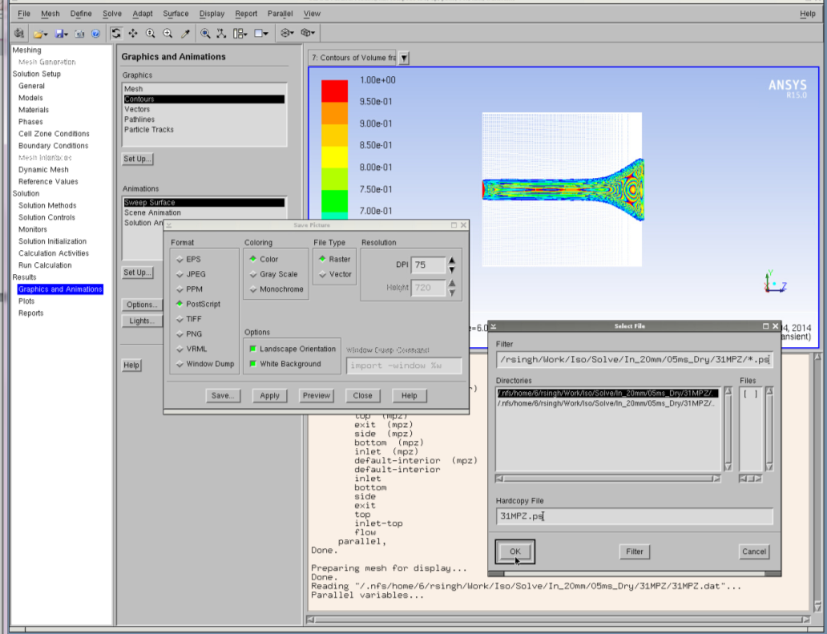

Figure 29: Graphics and Animations Save Picture window.

1. **Creating an Interface**

Navigate to the **Menu** bar, select **Surface**, and then a number of options appear in the drop-down. From the drop-down, select **Iso-surface**. Here an iso-surface representing the interface is defined (Figure 30).

Surface → Iso-Surface

The Iso Surface dialog box appears.

* 1. Select Phase in the surface constant drop-down.
  2. Select Solvent in the phase drop-down.
  3. Specify 0.50 as iso value.
  4. Select Flow in zone.
  5. Specify Interface as surface name.
  6. Click Create button to generate Iso surface.
  7. Click Close button to close the dialog box.

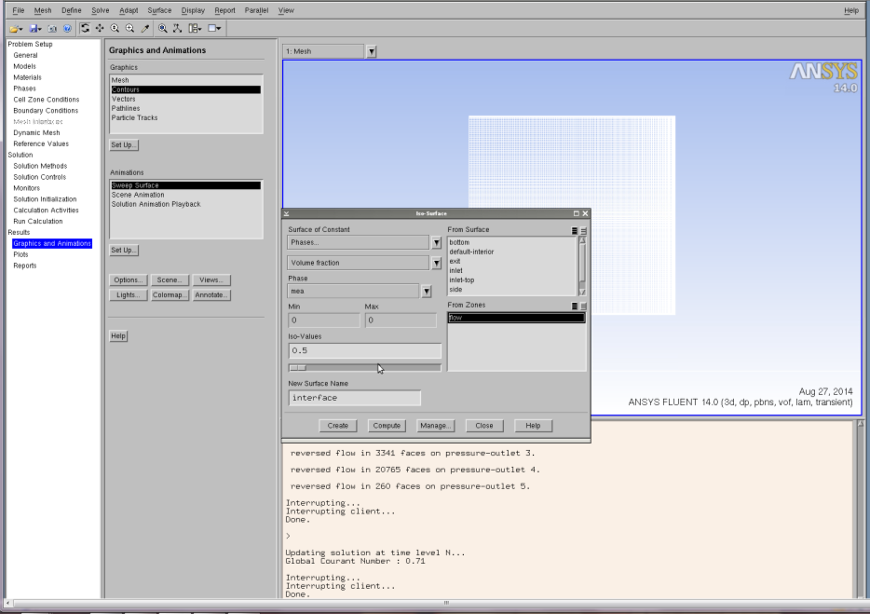

Figure 30: Graphics and Animations Iso-Surface window.

1. **Area of the Interface**

Navigate to the navigation panel, select **Reports**, and then a number of options appear in the task page. From the task page, select **Surface Integrals**,and click Setup. Here an iso-surface representing the surface is defined (Figure 31).

Report → Surface Integrals → Setup

The Surface Integral dialog box appears.

* 1. Select Area in the report type drop-down.
  2. Select Interface to Surface box.
  3. Click Compute to calculate the area of the interface. The computed value of the area appears in the dialog box, as well as in the console.
  4. This value can also be saved in the file by clicking the Save Output Parameter.

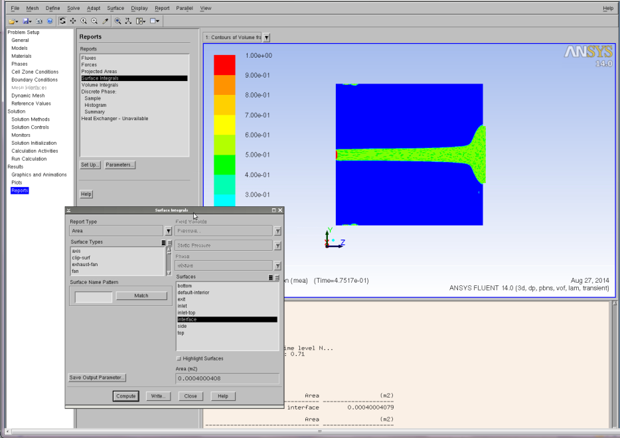

Figure 31: Reports Surface Integrals window.

1. **Liquid Holdup**

Report → Volume Integrals → Setup

The Volume Integral dialog box appears (Figure 32).

1. Activate the Volume-Average check boxes.
2. Select Phases in the Field Variable drop-down.
3. Select Solvent in the Phase drop-down.
4. Select Flow in the Cell Zones.
5. Click Compute to calculate the liquid holdup. The computed value of the holdup displays in the dialog box, as well as in the console.
6. This value can also be saved in the file by clicking the Save Output Parameter.

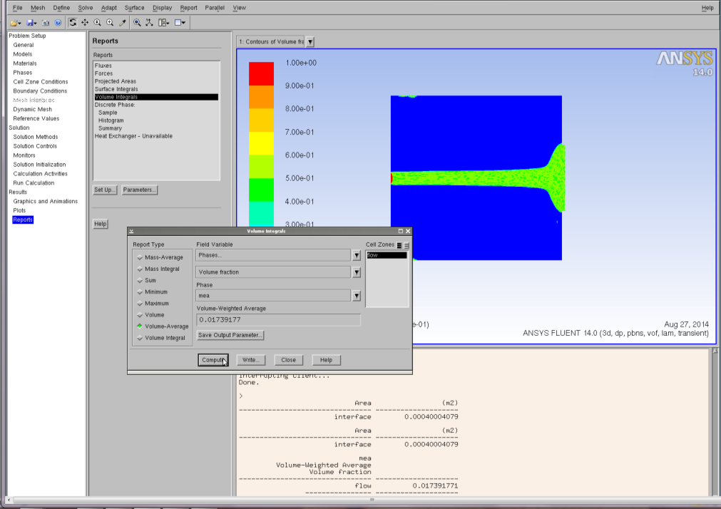

Figure 32: Reports Volume Integrals window.

1. **Film Thickness**

The above steps have been viewed in the context of rivulet flow. The measurement of film thickness was performed for the case of full film flow. Therefore, the user must load the appropriate .cas file (film.cas) and follow the procedure outlined for running such a Fluent simulation. As noted earlier, this file is available in the CFD Product bundle of which this User Manual is included. Once the simulation has been run, the user may perform the steps outlined here for calculating film thickness.

Reports → Surface Integrals → Setup

The Surface Integral dialog box appears (Figure 33).

* 1. Select Integral in the report type drop-down.
  2. Select Custom field functions for field variable.
  3. Select Film-Thickness in the Next Bottom box.
  4. Select Plane-Film in the Surface box.
  5. Click Compute to calculate film thickness. The unit of the computed film thickness value is mm.
  6. This value can also be saved in the file by clicking the Save Output Parameters.

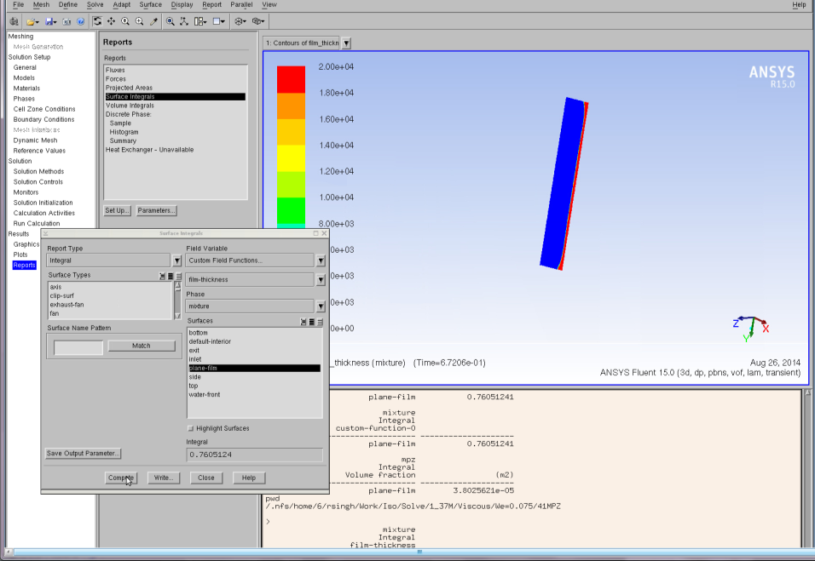

Figure 33: Reports Surface Integrals window.

1. OpenFOAM Simulation Case Study
   1. Simulation Overview and Prerequisites

A subset of the Fluent simulations were also conducted using OpenFOAM [2]. Thus, the general problem setup is identical to that in Fluent consisting of three dimensional gas-liquid two phase flow down an inclined plate. The problem dimensions and physical properties of the phases are as before.

* 1. Simulation Setup

It is assumed that the users have access to OpenFOAM on their chosen platform. For details on installation of OpenFOAM, refer to <http://www.openfoam.org/download/>. For information on the file structure of OpenFOAM, please see the following link <http://www.openfoam.org/docs/user/case-file-structure.php#x17-930004.1>. This link explains the file structure for geometries, physical parameters, initial conditions, etc. Finally, the following link is a Volume of Fluid module tutorial of OpenFOAM <http://www.openfoam.org/docs/user/damBreak.php>.

The necessary files for building the basic OpenFOAM VOF simulation for rivulet flow down an inclined plate are available in the CFD Product bundle of which this User Manual is included. The available case is for water, as the other simulations may be duplicated by modifying the appropriate physical and transport properties of the fluid. The folder contains the mesh file but not the generated mesh. The latter can be generated within OpenFOAM once it is installed.

1. References

[1] ANSYS FLUENT Theory Guide. 2011.

[2] User Guide Open FOAM 2.3.0., 2014, Bracknell, UK, OpenCFD Ltd.

OpenFOAM Wetted Wall Simulation Package

1. Introduction

CCSI aims to develop state-of-the-art computational modeling and simulation tools to accelerate the commercialization of carbon capture technologies from discovery to development, and eventually the widespread deployment to hundreds of power plants, through a partnership among national laboratories, industry and academic institutions. The ultimate goal of CCSI Toolset is to provide end users in industry with a comprehensive, integrated suite of scientifically validated models, delivering uncertainty quantification, optimization, risk analysis and decision making capabilities [1].

This user manual contains the installation guides, theoretical background, and one case study for the CFD model developed to simulate the hydrodynamics of falling film in wetted wall column, coupled with mass transfer and absorption of gas species. The liquid falling film contains aqueous solutions of ethanolamine (MEA) used as a CO2 stream scrubbing [liquid](https://en.wikipedia.org/wiki/Liquid). The fundamental physical and chemical processes behind this is: CO2 is absorbed and removed from the exhaust of coal- and gas-fired [power plants](https://en.wikipedia.org/wiki/Power_plant) by chemical reactions through scrubbing processes using highly CO2 soluble and reactive solvent, MEA.

The multiphase CFD models fully equipped with chemistry and mass transport capabilities are established to predict the overall CO2 mass transfer rate. The models are built upon OpenFOAM (Open source Field Operation and Manipulation), a C++ toolbox for the development of customized numerical solvers, and pre-/post-processing utilities for the solution of continuum mechanics problems, including computational fluid dynamics (CFD). In the case study, the key input parameters and output variables will be identified.

1. Installation

CCSI wetted wall simulations are custom OpenFOAM simulations. For that reason, the general installation procedure in this user manual follows that of OpenFOAM [2]. **Note:** The version of OpenFOAM needs to be 2.2.0. In this session, only the wetted wall model package installation procedure will be covered in details. The general OpenFOAM steps can be referred to the OpenFOAM manual.

* 1. Prerequisites
     1. Hardware

The hardware requirements for this CCSI model follow exactly the same as that for OpenFOAM. OpenFOAM is only supported on UNIX/LINUX platform, therefore a UNIX/LINUX server or system is required to install, build, and run the simulation.

* + 1. Software

The software requirements for wetted wall simulation follow that of OpenFOAM as well. A C++ compiler for the given platform is required for the compilation. Compilation has been tested with the following C++ compilers and versions:

* GCC: 4.5.0 and above
* LLVM Clang: 3.4 and above
* Intel ICC: 14.0.1
  1. Third Party Software

Open-source, multi-platform data analysis and visualization application ParaView is recommended for the OpenFOAM simulation post-processing purpose. Users can download ParaView software online from <http://www.paraview.org/>.

* 1. Product Installation

It is assumed that users have downloaded OpenFOAM source files, set environment variables, and built the sources under $InstallDir/OpenFOAM. This session will only describe the steps to build CFD models for CCSI wetted wall column package.

Custom code for CCSI wetted wall column simulation are available on this site: <https://www.acceleratecarboncapture.org/product/cfdmodelsbundle>.

Create a directory for CCSI wetted wall column package, for example, in LINUX, $HOME/CCSI/WWC. Once obtaining WWC directory from the above CCSI site, the WWC directory should include the following folders and files:

**Make**

Allwclean

Allwmake

alphaCourantNo.H

alphaEqn.H

alphaEqnSubCycle.H

c1Eqn.H

c2Eqn.H

c3Eqn.H

correctPhi.H

createFileds.H

interFoam.C

interFoam.dep

Makef

pEqn.H

setDeltaT.H

UEqn.H

**Note:** **Make** is a folder and the rest of them are files.

Copy the **wmake** folder from the OpenFOAM root directory to the WWC directory by simply typing the following command.

cp –r $InstallDir/OpenFOAM/wmake $HOME/CCSI/WWC/

To keep the root directories intact and implement the wetted wall model package as an individual solver library, a new environment path needs to be set. Type the following commands:

export WM_DIR=$HOME/CCSI/WWC/wmake

export FOAM_USER_APPBIN=$WM_DIR

In the wetted wall column directory (e.g., $HOME/CCSI/WWC), type wmake to build the model. The building process will compile object files in $HOME/CCSI/WWC directory and generate an executable interFoam file there. This interFoam file can be copied to the user’s project directory and serve as an execute command to run the corresponding project. Alternatively, users can also refer to this directory ($HOME/CCSI/WWC) to run interFoam for their own project. See the case study for details.

**Note:** This new executable interFoam is not the same as that from the OpenFOAM interFoam solver because the new created interFoam has the capability to simulate both hydrodynamics and chemical reaction of gas-liquid flow. To avoid any confusion, the user may choose to rename the new generated interFoam to e.g., CCSI_interFoam.

1. Simulations

Users can choose serial execution or parallel execution to run a CCSI wetted wall CFD simulation. The case study in Section 5.0 Case Study will provide guidance for parallel simulation. Users can also refer to Section 3.4 of OpenFOAM User Guide [3] to get more information. In this session, we provide a brief introduction on the input file, output files, and the post-processing.

* 1. Input File

The same as all other OpenFOAM input files, the system reads input data files from three sub-directories when a.out runs. The data may vary case by case, but the key parameters specified in the corresponding input files are listed in the hierarchical chart as shown in Figure 34.

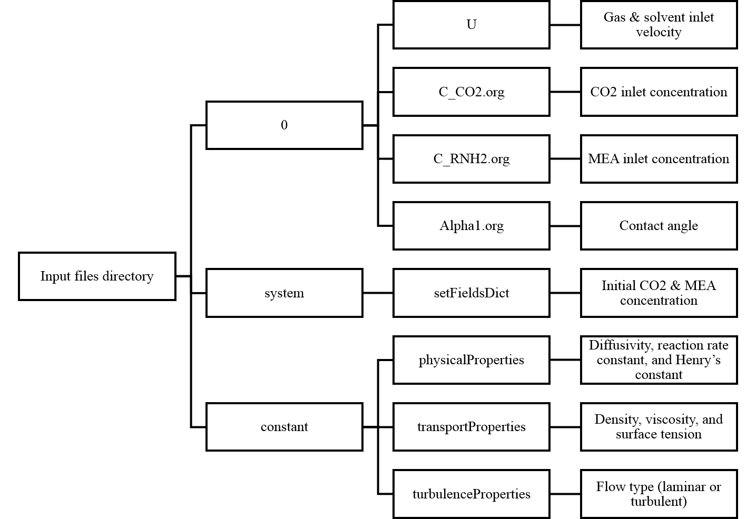

Figure 34: Input directories and files.

* In the 0 directory, solvent inlet and gas inlet velocity can be edited in U file, CO2 inlet concentration can be edited in c_CO2.org file, MEA inlet concentration can be edited in c_RNH2.org file, and contact angle can be edited in alpha1.org file.
* In the constant directory, user can choose to edit the modified Henry’s constant (reciprocal of the original Henry’s constant value), reaction rate constant, CO2 diffusivity in solvent, MEA diffusivity in solvent, CO2 diffusivity in gas mixture, etc., in physicalProperties file. In addition, user can also choose to edit density and viscosity of the liquid and gas phase, as well as the surface tension in transportProperties file. Furthermore, user can select laminar or turbulent modelling in turbulenceProperties file.
* In the system directory, initial condition of the CO2 and MEA concentration can be set in setFieldsDict file.

**Note:** All parameters are well commented for the sample input files.

Sample input files, which is also the case study input files can be downloaded from the CCSI site: <https://www.acceleratecarboncapture.org/product/cfdmodelsbundle>.

* 1. Output

OpenFOAM output containing the data of volume of fraction, CO2 and MEA concentration, velocity, pressure, etc., throughout the domain is stored in every time output directories.

* 1. Post-Processing

Users can use ParaView, or their own preferred tools to do post-processing analysis with their simulation results. To open a case directly from ParaView, the user creates a dummy file with the extension .OpenFOAM. See details from OpenFOAM User Guide [3].

* 1. Overall Simulation Procedure Summary
* Download and install the OpenFOAM software

[http://www.openfoam.org/download](http://www.openfoam.org/download/)

* Download the wetted wall column custom code

<https://www.acceleratecarboncapture.org/product/cfdmodelsbundle>

* Copy the wmake directory from OpenFOAM root directory to WWC directory

cp –r $InstallDir/OpenFOAM/wmake $HOME/CCSI/WWC/

* Set up environment path

export WM_DIR=$HOME/CCSI/WWM/wmake

export FOAM_USER_APPBIN=$WM_DIR

* Compile Wetted Wall Column package

wmake

* Setup case and adjust the corresponding parameters based on users need (follow the OpenFOAM User Guide [3])
* Run case

interFoam

* Post-processing analysis (e.g., in ParaView)

1. Theoretical Background

VOF model will be employed to solve for two Newtonian, incompressible, isothermal, and immiscible fluids by tracking the volume fraction ($α$) of each phase in the volume fraction equation. The volume fraction equation is introduced as

|  |  |  |
| --- | --- | --- |
|  | $$\frac{∂}{∂t}\left(α_{L}\right)+∇∙\left(α_{L}u\right)=0$$ | (1) |

where $u=\left(u,v,w\right)$, denotes the velocity in x, y, and z direction, respectively. The subscript $L$ represent the liquid phase property. The gas phase volume fraction $α_{g}$ can then be calculated as

|  |  |  |
| --- | --- | --- |
|  | $α_{g}=1-α_{L}$. | (2) |

where the subscript g represents gas phase property.

The continuity and Naiver-Stocks equations are given by

|  |  |  |
| --- | --- | --- |
|  | $$\frac{∂ρ}{∂t}+∇∙\left(ρu\right)=0$$ | (3) |
|  | $$\frac{∂}{∂t}\left(ρu\right)+∇∙\left(ρuu\right)=-∇p+∇∙\left[μ\left(∇u+{∇u}^{T}\right)\right]+ρg-F_{st}$$ | (4) |

where density $ρ$ and viscosity $μ$ can be defined by a volume fraction averaged form as

|  |  |  |
| --- | --- | --- |
|  | $$ρ=α_{L}ρ_{L}+α_{g}ρ_{g}$$ | (5) |
|  | $$μ=α_{L}μ_{L}+α_{g}μ_{g}$$ | (6) |

$F_{st}$, the surface tension force, can be expressed using the CSF model proposed by Brackbill et al. [4].

|  |  |  |
| --- | --- | --- |
|  | $$F_{st}=σ_{st}κδn$$ | (7) |

where $σ_{st}$ is the surface tension coefficient, $κ=-∇∙n$ represents the curvature of the surface, $δ$ is the interface Dirac delta function, and $n$ is the interface normal vector.

The one-fluid equation [5] taking convection, diffusion, and interface mass transport into account will be applied to calculate gas concentration in both phases using only one equation throughout the domain.

|  |  |  |
| --- | --- | --- |
|  | $$\frac{∂c_{j}}{∂t}+∇∙\left(uc_{j}-D_{j}∇c_{j}-Γ_{j}\right)-W_{j}=0$$ | (8) |

with

$$Γ_{j}=-D_{j}\frac{c_{j}\left(1-k_{H,j}\right)}{α_{L}+k_{H,j}\left(1-α_{L}\right)}∇α_{L}$$

$$D=\frac{D_{L}D_{g}}{α_{L}D_{g}+\left(1-α_{L}\right)D_{L}}$$

where $c_{j}$ represents the concentration for gas species $j$, $D$ is the local diffusivity computed by the harmonic interpolation, and $k_{H}$ denotes the dimensionless Henry’s constant ($k_{H}=c_{g}/c_{L}$).

**Note:** The concentration of gas and liquid phase normally has a discontinuous jump at the interface caused by different solubility within the respective fluid phases. The term ($Γ_{j}$) in Equation (8) accounts for this behavior by taking the Henry’s Law into consideration. By applying the above equation, the concentration of oxygen can be computed as discontinuous across the interface. The last term ($W_{j}$) in Equation (8) is the production term related to the chemical reaction rate.

The chemical reaction of CO2 absorption by MEA can be expressed as

$$CO_{2}+2RNH_{2}→RNHCOO^{-}+RNH_{3}^{+}$$

where $R=-CH_{2}CH_{2}OH$. The reaction rate constant $k (l/mol∙s)$ is calculated based on the correlation proposed by Hikita et al. [6]

|  |  |  |
| --- | --- | --- |
|  | $$\log_{10}{k}=10.99-2152/T$$ | (9) |

After that, the reaction rate of CO2 can be calculated as

|  |  |  |
| --- | --- | --- |
|  | $$W_{CO_{2}}=kc_{CO_{2}}c_{MEA}$$ | (10) |

To simulate a non-reactive gas absorption across liquid film, the user can set the reaction rate constant $k$ to be zero to drop the $W$ term in Equation (8).

1. Case Study

In this section, we will set an example, CO2 mass transfer across MEA film, to explain how input files are created for what conditions: initial condition, boundary condition, and operating condition (temperature, pressure, etc.).

The case study input files, which are the same as the sample files shown in Section 3.1 Input File, can be downloaded from the CCSI site: <https://www.acceleratecarboncapture.org/product/cfdmodelsbundle>.



Figure 35: Schematic picture of the geometry.

* 1. Geometry

As shown in Figure 35, the geometry of this example is designed to be a 2-D flat plane. The x-axis denotes the thickness of the film layers perpendicular to the plate wall. The y-axis describes the   
stream-wise direction of the vertical film along the wall. The oxygen gas flows countercurrently with water solvent throughout the domain. The length of the geometry, $L$, is 90.9 mm and the width, $W$, is 5.25 mm. Inlet and outlet sizes for gas are set to be 0.1 mm. The solvent inlet is chosen to be 1mm, while the solvent outlet is set to be 2 mm.

If users choose to download the case study files under the directory of $HOME/CCSI/CASE, then the geometry information is stored in $HOME/CCSI/CASE/constant/polyMesh/blockMeshDict.

* 1. Boundary and Initial Conditions

Table 3 lists all the parameters used in the computational calculation. The boundary condition for the left, right, bottom and up walls is set to be non-slip condition.

At solvent inlet, MEA velocity is given as 0.1768m/s so that the type of flow will be laminar.

At solvent outlet, mass concentration gradient is given at zero because the flow is assumed to be at a fully developed condition.

|  |  |  |
| --- | --- | --- |
|  | $$\frac{dc}{dy}=0$$ | (11) |

For gas inlet, 0.1 mol/m3 CO2 gas is released to the domain at the velocity of $0.2317m/s$.

For incompressible flow, relative pressure (pressure difference) rather than the absolute pressure is more important. Therefore, the pressure value at gas outlet is set to be zero.

|  |  |  |
| --- | --- | --- |
|  | $$p=0$$ | (12) |

For initial conditions, the testing domain is placed at zero atm pressure and the domain is filled with 0.1 mol/m3 CO2 gas. The time step size is adjusted to be 1e-5 s for the simulation. The case is initially set to run for 0.5 seconds. The grid number is set to be 200 and 500 in x and y direction, respectively.

Table 3: Values of Input Parameters

| Parameters | Value and Unit |
| --- | --- |
| Temperature | 25°C |
| Pressure | 0 atm |
| Solvent Inlet Velocity | 0.1768m/s |
| Gas Inlet Velocity | 0.2317m/s |
| Inlet CO2 Concentration | 0.1mol/m3 |
| CO2 Diffusivity in Gas | 1.6e-5m2/s |
| CO2 Diffusivity in Solvent | 1.0e-9m2/s |
| MEA Diffusivity in Solvent | 1.0e-9m2/s |
| RNHCOO Diffusivity in Solvent | 1.0e-9m2/s |
| Solvent Contact Angle | 40 |
| Density (Solvent, Gas) | 1000,1 kg/m3 |
| Kinematic Viscosity (Solvent, Gas) | 3e-6, 1.48e-5 m2/s |
| Surface Tension | 0.07 kg/s2 |
| Henrys Constant of CO2 in MEA | 0.4669 (code use 1/0.4669=2.1418) |
| Reaction Rate Constant | 5.9178 m3/mol s |

* 1. Run in Serial or Parallel

The default setting in OpenFOAM is to run simulation in serial. This example shows how to run simulation in parallel. First of all, the detailed parameters regarding the decomposition of geometry and fields need to be specified in $HOME/CCSI/CASE/system/decomposeParDict. Then execute the decomposition using command decomposePar and finally run the case by simply typing the following command in the case study directory.

mpirun –np 16 $HOME/CCSI/WWC/interFoam -parallel > run.txt

In the case study, 16 cores are used to run the simulation. In addition, the executable file interFoam is obtained from the download directory of wetted wall model package. **Note:** To run simulation in parallel, the OpenMPI library also need to be installed to the UNIX/LINUX system.

1. Reporting Issues

Send an e-mail to [ccsi-support@acceleratecarboncapture.org](mailto:ccsi-support@acceleratecarboncapture.org) to report a CCSI wetted wall model specific issue.

1. References

[1] PNNL ARRA Report on the Development of Full Scale CFD Simulations of a Solid Sorbent Adsorber and Regenerator and the Development of an Approach for UQ of CFD Simulations, CCSI, February 24, 2012, DOE and NETL.

[2] OpenFOAM – Open source Field Operation and Manipulation, Version OpenFOAM 2.2.0. Download available <http://www.openfoam.org/download/>.

[3] OpenFOAM User Guide <http://cfd.direct/openfoam/user-guide/>.

[4] Brackbill, J.U., D.B. Kothe, and C. Zemach, A Continuum Method for Modeling   
Surface-Tension. Journal of Computational Physics, 1992. 100(2): p. 335–354.

[5] Haroun, Y., D. Legendre, and L. Raynal, Direct numerical simulation of reactive absorption in gas-liquid flow on structured packing using interface capturing method. Chemical Engineering Science, 2010. 65(1): p. 351–356.

[6] H. Hikita, S. Asai, H. Ishikawa, M. Honda, The kinetics of reactions of carbon dioxide with monoethanolamine, diethanolamine and triethanolamine by a rapid mixing method, Chem. Eng. J. 13 (1977) 7–12.